Article
AUMOR: Augmented-Reality Based Mobile Application for University Orientation
Muhammad Nadeem ^{1,}*, Melinda Oroszlanyova ¹, Pauly Awad ¹, Hasan Ozkan ², and Svetlana Beryozkina¹
Academic Editor: Firstname Lastname
Received: date
Revised: date
Accepted: date
Published: date
Citation: To be added by editorial staff during production.
Copyright: © 2025 by the authors. Submitted for possible open access publication under the terms and conditions of the Creative Commons Attribution (CC BY) license (https://creativecommons.org/licenses/by/4.0/).
¹ College of Engineering and Technology, American University of the Middle East, Egaila 54200, Kuwait
² College of Business Administration, American University of the Middle East, Egaila 54200, Kuwait

¹ *Correspondence: Muhammad.nadeem@aum.edu.kw
Abstract: Fresh engineering students are often required to absorb a large amount of new information within a short period of time, which can be both academically and emotionally challenging. In response to this challenge, this study introduces AUMOR, a mobile application designed to enhance university orientation by delivering contextual information at the point of need. The application integrates GPS-based localization with QR code triggers to provide real-time, location-specific guidance and interactive content through an augmented reality (AR) interface. It uses GPS functionality to provide real-time location-based services including information about academic buildings, student services, and recreational facilities. The QR code placed on devices and lab equipment provides relevant information upon scanning. We present the development process including its conceptual framework, design considerations, and implementation plans. Results demonstrate that AUMOR significantly improves spatial awareness during orientation by providing them with important information when needed. The system offers a scalable solution for smart campus environments and contributes to the broader field of context-aware mobile learning and AR-assisted navigation.
Keywords: Augmented Reality (AR), Mobile application, University orientation, GPS Navigation, QR Codes, Technology acceptance model (TAM), Context appropriate information
- Introduction
Every year, many students leave college and enter universities to become successful professionals. As institutions of higher learning, universities are crucial for helping students develop their intellectual capacity and prepare for workforce demands [1], [2]. Fresh students often face problems in navigating campus and obtaining information about related buildings and departments. They also face problems in labs due to a difficult transition from theoretical coursework to practical work. They have to learn about safety protocols and equipment crucial for smooth workflow. Before being permitted to work in the lab, students at many universities must also undergo the lab orientation program. Furthermore, campus life often feels like a survival challenge as students race between buildings, get lost indoors, and juggle multiple apps that do not show what is inside a building or how to reach services on time. The result is not just tardiness; it is a steady drain on energy, productivity, mental clarity and confidence [3]. This is less a time-management issue than a design problem, revealing the need for a smarter, student-centric tool to assist teachers in their work. This problem can be addressed through a personalized campus companion for students which helps them in finding information about the nearby labs and equipment inside it, classrooms, study zones, cafés, and library rooms thus making daily academic life faster, smarter, and calmer, avoiding the chaotic, inefficient days that occur without it [4].
University orientation programs serve as critical transitional experiences for new students entering higher-education institutions. Students who participate in these programs often performed better academically than those who did not attend the orientation program. Due to reasons the orientation of campus including labs is a crucial part of new student onboarding and improves their chances of success. Orientation not only motivates students but also helps them build solid social networks and adjust to the academic environment more effectively [5]. But traditional orientation methods may not always adequately address the diverse needs and preferences of modern learners and may be expensive. For example, orientation fees in the U.S. range from $100 to over $500 per student, with UNC-Chapel Hill charging $232, Stanford $525, and Canadian universities $63 average. Australia uses the Student Services Fee for free "O-Week" events [6]. European orientations are typically free and funded by universities and student unions in the EU. Orientation is a valuable investment in students’ success. In 2024, the global augmented reality market was valued at $83.65 billion. From 2025 to 2030, a compound annual growth rate of 37.91% is anticipated [7].
University orientation programs often face challenges in effectively assisting new students in navigating campus facilities, accessing relevant information, and fostering a sense of belonging among them. Traditional methods may not fully accommodate to the needs and preferences of modern learners, leading to inefficiencies and gaps in the orientation process. In recent years, advancements in mobile technology have opened new avenues for enhancing the orientation process of new intake of students [8]. Mobile applications have emerged as powerful pedagogical tools for university students. The integration of AR technology with GPS and QR codes into mobile applications offers immersive and interactive experiences by blending digital contents with the physical world [9]. By superimposing virtual information in real-life environments, AR applications can provide students with contextualized guidance, information, and engagement opportunities during university orientation.
The challenges faced by new students during the orientation process motivated us to explore the potential of mobile based AR to develop an application, AUMOR (American University of the Middle East Orientation using Augmented Reality), tailored specifically for university orientation. This application will provide incoming students with a seamless and intuitive tool for accessing relevant information. The objectives of this study are as follows.

- Design and implementation of a mobile application integrating GPS navigation, QR code scanning, and AR features to facilitate university orientation by providing information about the buildings as well as lab equipment.
- Conducting usability testing and user feedback sessions to assess the ease of use, functionality, and user experience of AUMOR.
- Measuring the effectiveness of the application in supporting students' orientation experience, including their ability to navigate campuses and access to information.

The students can easily access information anytime and anywhere using the app installed on their smartphones or tablets, facilitating a smoother transition into otherwise challenging university life by creating immersive and interactive experiences that engage them in the campus environment. This investigation also gives valued insights and practical solutions for enhancing university orientation practices and transition to university life through the development and assessment of an AR mobile application.

- Literature Review
Universities often conduct orientation programs before the start of the academic term that are designed to provide incoming students with essential information, university policies, procedures, and academic requirements and may include presentations, campus tours, information sessions, and campus events and activities. Many universities also offer online orientation resources to supplement in-person orientation sessions [10], [11] permitting learners to access information according to individual pace and schedules.

  - Role of Mobile Applications in Education
Mobile applications have drastically changed educational methods as well as the ways of students’ access, engagement with educational content. The pervasive use of smartphones has learning experiences that go beyond the limitations of traditional classrooms through flexibility, interactivity, and personalization [2]. A recent literature review suggests that there has been a substantial increase in mobile learning research between 2018 and 2022 [12]. The popularity of mobile devices stems from the accessibility offered, enabling students to connect with educational matters any time and location. They avert geographical and temporal barriers to learning crucial in university settings where students have to balance multiple responsibilities [13] by providing easy access to resources, significantly enhancing student engagement and motivation [14]. Moreover, the availability of interactive and personalized multimedia features caters to the diverse learning styles, resulting in deeper cognitive engagement in the learning process [15]. The learning pathways can be adjusted dynamically for individual student progress and performance, supporting innovative instructional methods, such as microlearning [16]. Through a meta-analysis of 15 studies with 962 participants, Chandran et al. [17] demonstrated that the use of mobile applications considerably improves the academic performance of students when compared to traditional methods. Furthermore, applications enhance collaborative and communicative practices in educational settings by effectively bridging the psychological and pedagogical gaps between learners and instructors (Park, 2011). Mobile computer-supported collaborative learning (mCSCL) has been reported to improve collaborative as well as critical 21st-century skills invaluable for future academic and career success [18]. Beyond instructional applications, mobile apps have significantly streamlined administrative and support functions in educational institutions. Universities use dedicated apps for operational aspects of academia thereby enhancing overall operational efficiency [17], [19]. The introduction of mobile-based assessment and feedback has made it possible for educators to have a real-time insight into students’ progress. Also, the analysis of huge amounts of digital data makes it possible to monitor the student engagement and develop adaptive instructional strategies [13]. To cut short, mobile applications have become integral part of the current educational ecosystems, substantially improving educational outcomes.

  - GPS and QR Code Technologies in Navigation Apps
The integration of Global Positioning System (GPS) and Quick Response (QR) code technologies in mobile apps has significantly enhanced their functionality, accessibility, and usability [20], [21]. The GPS system was created in the United States, where an atomic clock is synchronized with all 24 of the satellites orbiting the earth. Each satellite continuously broadcasts its position coordinates and the precise time of its placement. All GPS portable devices use location data from at least four satellites to establish their position. After that, the gadget determines a position fix at its present location. GPS coordinates can be enriched with contextual information, such as time spent and activities at a particular location, to provide more meaningful insights [22]. The accuracy and reliability of GPS are very important in navigation apps, particularly in urban environments with high-rise buildings and signal interference, resulting in signal loss in dense urban areas or indoor environments. This has stimulated the researchers to explore alternative positioning methods and hybrid solutions to improve navigation accuracy. QR code, on the other hand, is an image that encodes distinct data dots and black squares which can be instantly deciphered by utilizing the camera on a smartphone. It can streamline the delivery process by providing quick access to essential information, reducing the time needed for manual data entry and verification [23]. They are widely used in medical [24] and industry [25] for managing equipment repairs and maintenance by providing quick access to detailed equipment information significantly improving repair efficiency and reducing downtime. AR technology allows integration of GPS and QR codes into navigation applications by overlaying digital information, such as route directions, points of interest, and location-based alerts, onto a user's real-world environment in real time, enhancing situational awareness and navigation experience.

  - Previous Studies on Mobile Apps for University Orientation
Many universities are using mobile applications for students to explore the campus independently reducing the need for staff involvement saving resources that are typically required for guided tours. It also enhances student engagement through immersive and interactive experience, helping them to familiarize themselves with campus environments, degree programs, and course curricula reducing students' fear of failure or withdrawal [26]. The development of AR technology for campus orientation and tours was first introduced by Columbia University, which employed head-mounted displays along with GPS and orientation tracking to present campus visitors with tour information in the form of three-dimensional (3D) graphics [27]. Fu-Jen Catholic University was one of the pioneers in utilizing AR, specifically to help new students become familiar with the campus layout [28]. Similar initiatives were launched at Lehigh University and Columbia University, where AR apps were developed to help users identify buildings [29] providing comprehensive campus tours [30]. Finally, Mobile AR has been utilized at the Autonomous University of Nayarit to create an autonomous learning process that helps users discover campus locations by providing info about degree programs, syllabi, and the facilities on campus [31]. Some of these applications even offer features such as indoor location detection and tracking [32]. The Bowling Green State University used AR-based mobile apps to help visitors explore campus cultural activities or events and guide them to specific locations [33].
Some researchers used different multimedia content and features to enhance the effectiveness of the applications. Researchers at Yu et al. at Chung Hua University used audio and visual elements to provide information on the campus’ ecological environment, creating an environmentally friendly navigation system [34]. Some researchers used voice-command search for locating and sharing places [35]. Similarly, researchers at the University of Quindio introduced a 3D directional board in their app that led visitors to various campus locations [36]. At Mil. Nueva Granada University researchers integrated landmarks on campus that trigger mini games through location services and dynamic maps for guiding new students [37]. Others used images of the locations taken through a camera which are administered to spot locations and display related details on the screen [38]. Nguyen et al. designed an AR application to assist students who missed orientation week at Haaga-Helia University of Applied Science, allowing them to catch up on essential information [26]. Andri developed AR and virtual tour applications for students of the Management and Science University, which allow users access hidden details such as building descriptions, staff information, and cafeteria menus by pointing their smartphones at signboards. It also provides a virtual 360-degree panoramic view of the campus buildings and facilities for students working remotely [39]. Nadeem et al., designed an AR-based lab orientation application that was more supportive than traditional methods, helping students better understand laboratory equipment and safety rules [2]. AR can also improve spatial orientation skills, which are crucial for navigating new campus environments, and improve their spatial orientation skills of students using such an app compared to those who do not [40]. Durham University used the campus's Wi-Fi network to find users' positions and provide them with information required at the point of need, as and when needed [41]. The University of Huddersfield uses QR codes to supply context appropriate support and information at the point of need [42].
The integration of these technologies into AUMOR benefits by combining real-time location tracking with on-demand information retrieval to provide users with seamless navigation experience. The hot loading feature of this does not require any compilation and content can be updated at any time making this app useful for the students throughout their stay at the University due to its ability to deliver information at the point of need.

  - Theoretical Framework
This application integrates GPS, QR codes, and AR technologies to provide users with a seamless and enriched experience. GPS provides location-aware information during the navigation and QR codes serve as digital markers and can quickly retrieve specific multimedia contents upon scanning. AR technology overlays virtual information onto physical spaces delivering personalized, context-aware experiences that cater to the diverse needs and preferences of users during university orientation and thereafter.
Figure 1 shows four key theoretical perspectives of AUMOR that inform its design, development, and implementation are : 1) Situated learning theory, 2) information processing theory, 3) UX design principles, and 4) spatial cognition and navigation theory. Each theory contributes to the app's design, functionality, and user interaction. First, the Situated Learning Theory emphasizes the importance of context and social interactions in the learning process [43]. Within the context of GPS and QR code-based AR applications, embedding educational content, interactive challenges, and guided exploration into the user’s surroundings, the application facilitates experiential learning and knowledge acquisition that are directly relevant to the user’s context [44]. The design of AUMOR is also supported by information processing theory focuses on how learners acquire, process, and retain information [45]. By optimizing the presentation of information, providing scaffolding and guidance, and incorporating interactive elements, it can enhance users information-processing capabilities and facilitate effective learning and decision-making [46]. Drawing on principles such as simplicity, consistency, feedback, and affordance [47], UX design informs the development of application interfaces, navigation flow, and interaction design. By prioritizing user needs, minimizing cognitive load, and maximizing usability, it enhances user satisfaction and engagement with the AR experience [48]. Finally, Spatial cognition and navigation theory explores how individuals perceive, interpret, and navigate spatial environments [49]. AUMOR incorporates spatially aware features, such as GPS-based navigation, AR overlays, and landmark recognition, which enhances navigation efficiency and spatial understanding within the physical environment.
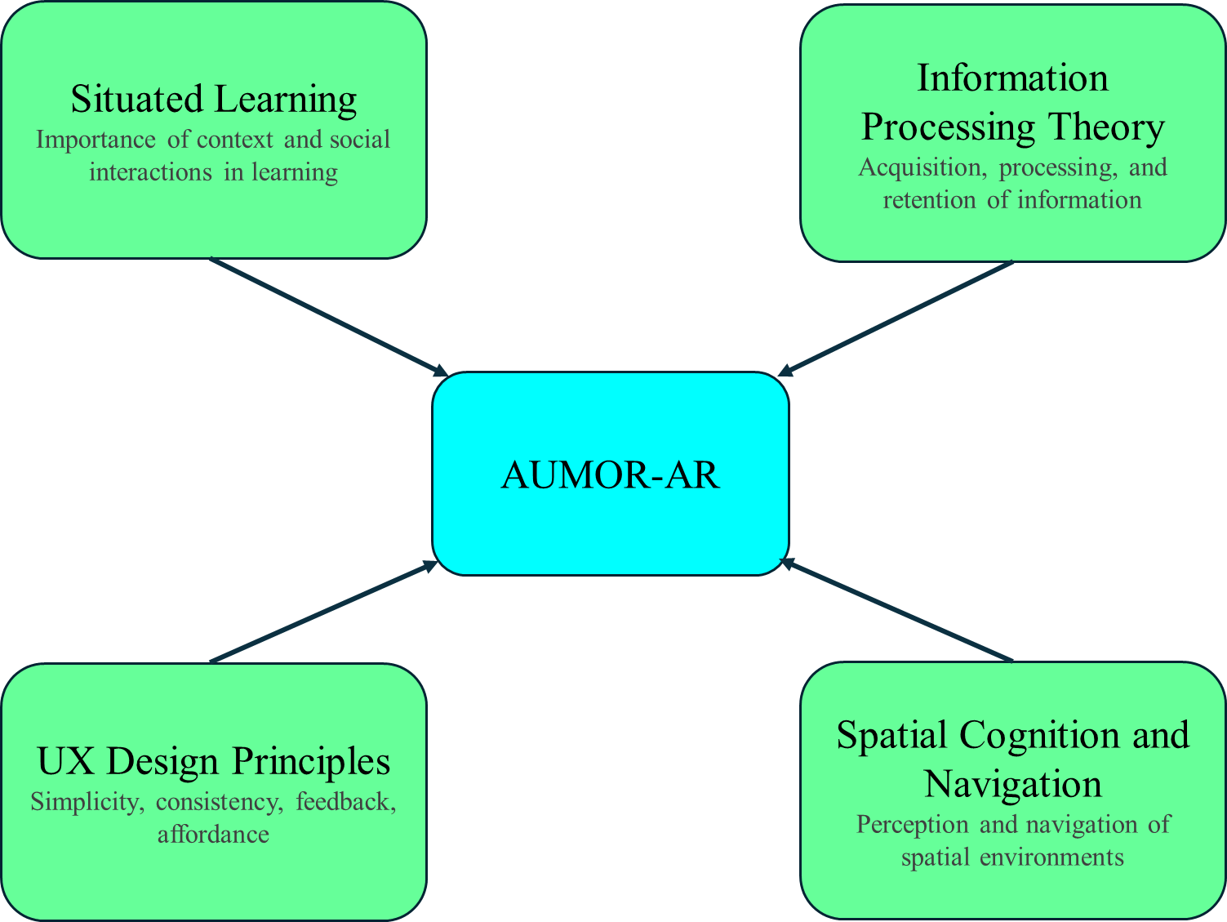
Figure 1. Theoretical Foundations of AUMOR Application.
Also, the adoption and use of information technologies have long been recognized as delivering both immediate and long-term benefits including improved performance, efficiency, and convenience. Though research on technology adoption gained prominence with the rise of computers but earlier studies lacked empirical insights into users’ responses to system performance and heavily on subjective performance measures that were often unreliable and weakly correlated with actual use. To address these shortcomings, Davis (1989) developed the TAM which specifically focuses on how users accept and use technology [50], [51]. By examining factors such as perceived usefulness, ease of use, and attitude toward technology, TAM helps predict and explain users' intentions to use GPS and QR code-based AR applications. Perceived usefulness (PU) refers to the extent to which a person believes that using a system enhances their performance, and perceived ease of use (PEOU) reflects the belief that using a system requires minimal effort. These two factors influence a user’s attitude toward using and behavioral intention to use a system. TAM also recognizes the role of external variables, such as system design, user characteristics, training, and support, which impact both PU and PEOU. Moreover, PEOU not only directly influences attitudes but also enhances PU, as users are more likely to find technology more useful if it is easy to use. The model is valued for its simplicity and often extended with additional constructs such as social influence, enjoyment, and facilitating conditions, to better capture diverse adoption contexts.

- Methodology
  - Research Design
In this study, we used a mixed-methods approach which used both quantitative and qualitative data analysis. It was mainly dominated by quantitative data captured perceptions, attitudes, and behavioral intentions providing primary basis for analysis and validation. It was supplemented with the qualitative data which was collected using open-ended questions allowing users to express their opinion freely and revealed deeper insights and contextual nuances that structured survey items might miss. This integration of both methods provided a holistic view of user acceptance and enhanced it validity and depth by bridging the objective metrics with subjective prospecives. It not only captures measurable perceptions but also uncovers nuanced feedback that might be overlooked in structured items. This approach is particularly valuable in evaluating apps, as user behavior and attitude can be influenced by a variety of contextual factors.

  - Data Collection Methods
    - Research Subject
A total of 128 participants, including undergraduate students and faculty members from the different departments of the university, took part in this research. Additionally, the participants had previously experienced augmented reality in one way or another.
    - Research Sample Selection
Students taught by the researchers were asked to take part in the survey via direct invitations during lectures. Students who volunteered to participate in this study were recruited for the study. The participants were selected in the sequences they contacted. No rewards or compensation were offered for participation. If a participant decided to withdraw the next participant was contacted to take his place. The survey was carried out on the AUM campus outside of teaching hours but within university hours. The participating students and facilitators belonged to the engineering and business schools.

    - Research Procedure
In case of students agreeing to take part, a meeting was arranged in which the participant and researchers were present who performed the evaluation and described the research and the procedure for carrying out the test to the participant(s). Respondents were briefed about the study purpose, anonymity, and consent before participation. Participants were made aware that their involvement in the study was entirely voluntary and that they might leave at any moment without facing any repercussions. They were provided with an Android smartphone with a pre-installed orientation application (AUMOR) inside the campus. The application includes a video tutorial to guide students and reduce their dependence on external assistance. After using the application, the participants were demanded to fill a paper-based form evaluating the comfort, usefulness, and helpfulness. The data was collected over a period of one month during summer 2025.

    - Questionnaire
We used a structured questionnaire as a primary instrument for collecting data. It was based on the TAM framework ensuring alignment with the established constructs. It was extended with additional elements relevant to the evaluation of AUMOR. The instrument combined quantitative and qualitative items to get user feedback and assess user perceptions, attitudes, behavioral intentions, and experiences. The final instrument contained 27 items, divided into seven distinct sections for logical flow as shown in Table 1. The complete list of questions and their wording is provided in Table A1 (Appendix A) for reference.

Table 1. Questionnaire structure and constructs
Section | Construct | Items | Type
Section 1 | Participant Demographics | Q1–Q4 | Categorical/Ordinal
Section 2 | Perceived Usefulness (PU) | Q5–Q9 | 5-point Likert
Section 3 | Perceived Ease of Use (PEOU) | Q10–Q15 | 5-point Likert
Section 4 | Attitude Towards Use (ATU) | Q16–Q19 | 5-point Likert
Section 5 | Behavioural Intention to Use (BIU) | Q20–Q22 | 5-point Likert
Section 6 | Actual Use (AU) | Q23–Q25 | Mixed (Likert/Open)
Section 7 | Open-Ended Feedback | Q26–Q27 | Open-ended text

All Likert items used a 5-point scale: 1 = Strongly Disagree to 5 = Strongly Agree.
    - Apparatus
In our study, we used Android-based smartphones for evaluating the application. The model used was Samsung Galaxy S21 SM-G991B with 128 GB storage, 8 GB RAM Dynamic AMOLED 2X display running Android 14. It has Exynos 2100 Octa-Core CPU processors and ARM Mali-G78 MP14 GPU graphics card. Alternatively, students could download the application from the repository by scanning a QR code and install it on their phones.

    - Research Ethics
This study involved human participants and required approval from the concerned authorities. The protocol was approved by the research committee at AUM (reference xxxx). The research required interactions faculty conducting the survey and the participants. Therefore, the researcher was aware of the participants’ identities, and anonymity was not possible. The questionnaire provided to the participants was anonymous and did not obtain any information that could help to identify them.

    - Research Hypotheses
The following hypotheses were developed based on TAM constructs and the structure of the questionnaire:
- H1: PEOU has a positive effect on PU.
- H2: PU has a positive effect on ATU.
- H3: PEOU has a positive effect on ATU.
- H4: ATU positively influences BIU.
- H5: PU positively influences BIU.
- H6: BIU positively influences AU.
A graphical illustration of research hypotheses is also provided in Figure 2.
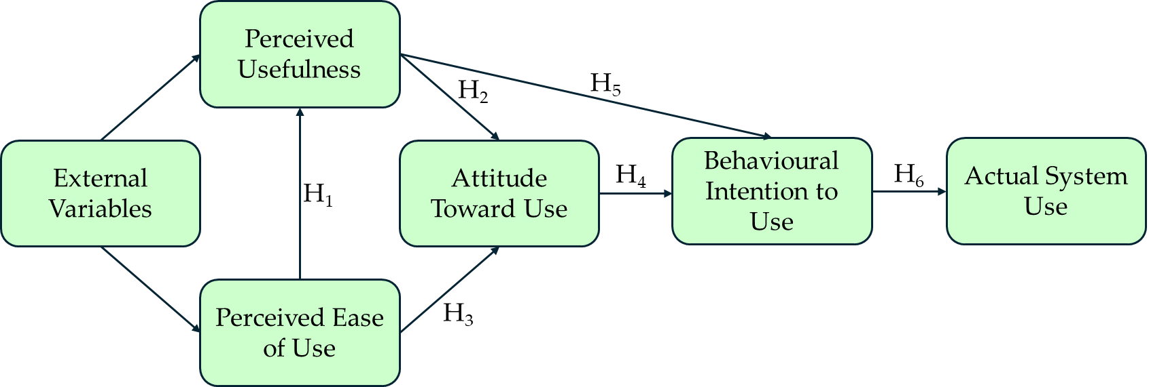
Figure 2. Illustration of TAM-based research hypothesis
  - Implementation Plan for University Orientation
    - AUMOR architecture
Figure 3 illustrates the architecture of AUMOR. It consists of a remote data server and a wirelessly linked mobile client application that runs on the platform communicating with each other using the JSON protocol. The user engages with the application by using the camera and GPS built into the device to scan the QR code and provide the user's position, respectively. Both the camera and GPS feed their data into the AR Display, which becomes the user's interaction layer with the application. The user request, which includes GPS coordinates or scanned QR information, is structured in JSON format and sent to the remote server. The AR content is stored on a server or repository such as GitHub in JSON-format. The server parses the incoming request, matches the data with the appropriate AR content, and sends a real-time JSON-formatted response containing AR assets such as text, images, or videos. AUMOR parses this response and displays these contents on the mobile display. One of the important feature of this app is hot reloading which allows to update the AR dynamically on the server without the need of recompilation saving time, resources, and simplifying content maintenance.
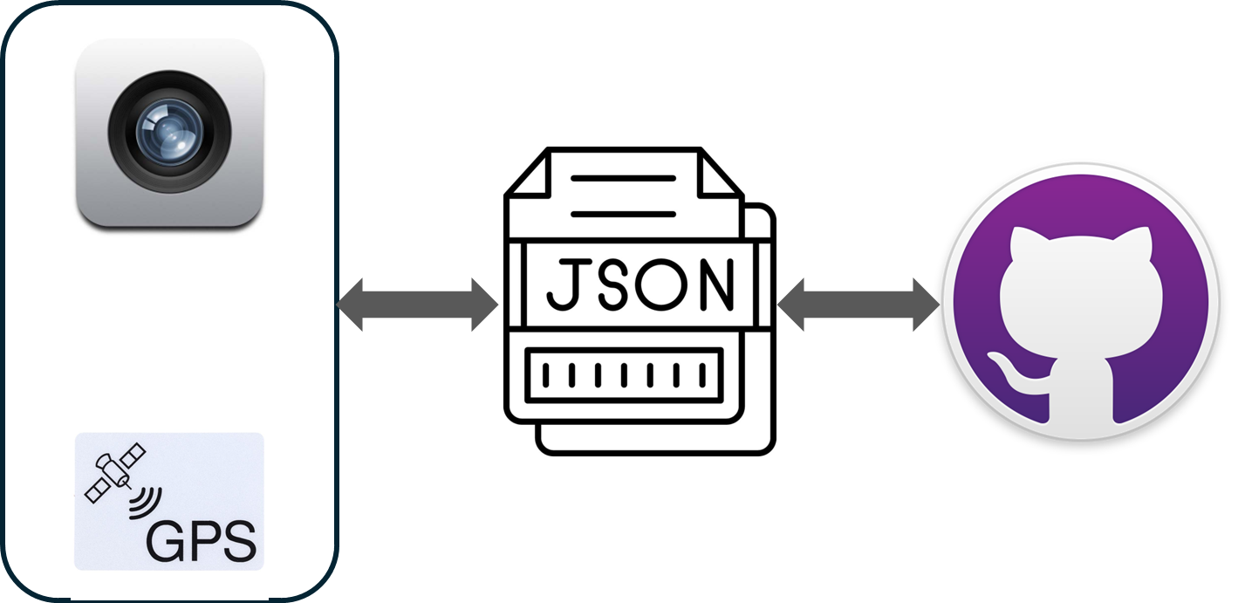
Figure 3. System architecture
    - Development Process of AUMOR
We used an incremental development model for mobile application development because of lower risk due to early testing, early basic working prototype, and flexibility to changing requirements. This iterative approach breaks down a project into smaller and manageable increments or iterations. Each iteration focuses on delivering a specific set of features or functionalities, allowing continuous improvement and adaptation throughout the development process. As shown in Figure 4, starting phase is the project planning one where we specify the goals and objectives of the application. We then identified the features such as GPS coordinates reading and QR scanning for the initial release which are the most critical features necessary to create a functional app. The focus was to create a stable and reliable foundation meeting the requirements of users. The requirements were collected through feedback from users and usability testing sessions which also identified areas for improvement. The development process was iterated by adding new features such as adding AR contents, tutorial, user authentication, and quizzes in the subsequent increments with each increment building upon the previous one, gradually expanding the app's capabilities. The app's performance and user engagement metrics were monitored to identify opportunities for optimization and refinement. An ongoing feedback loop with users was maintained throughout the incremental development process of the app.
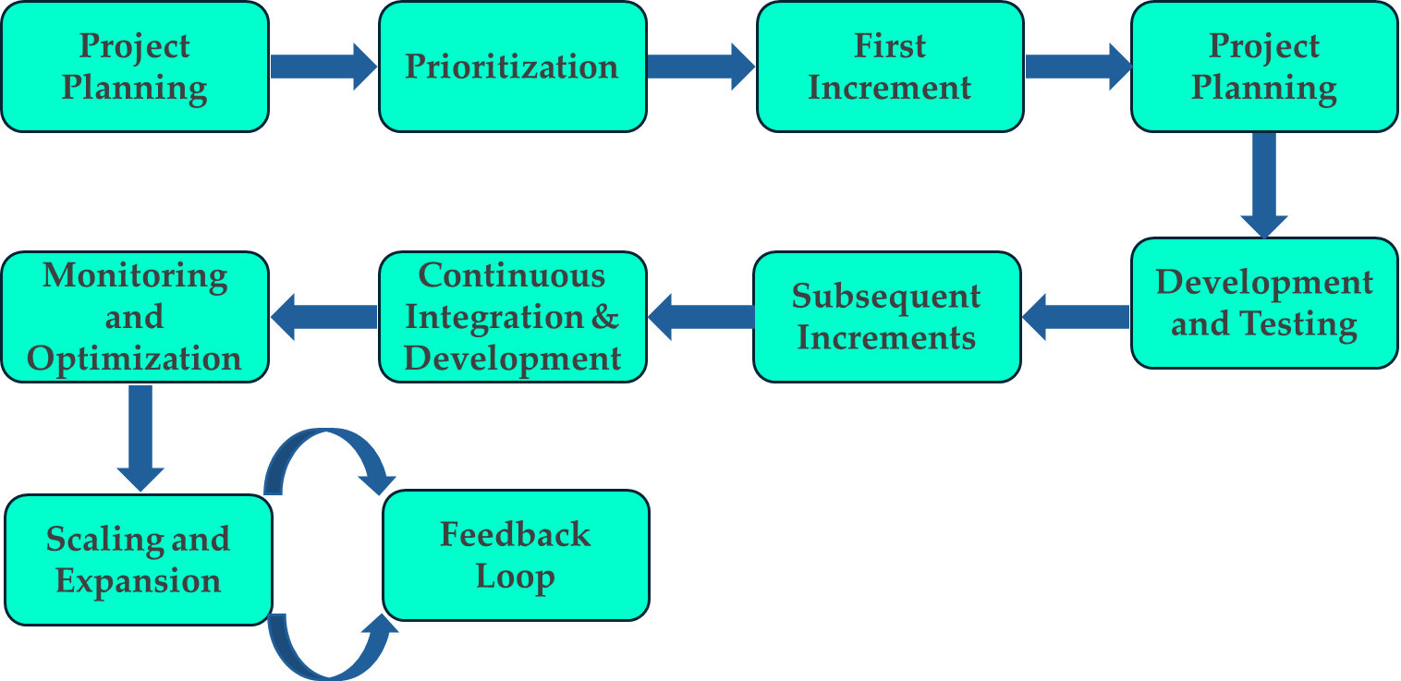
Figure 4. Incremental and iterative app development lifecycle
    - AUMOR Development Platform
The open-source Flutter framework, created by Google, was used for developing the application [52]. It is chosen for development due to its simplicity, ability to be customized, and scaling making it suitable for quick development. Additionally, it can generate natively compiled applications for different target platforms such as desktop, web, and mobile from a single codebase which can run on both iOS and Android. Its reactive structure allows developers to view changes instantly without losing state by turning on hot reload capabilities [53], [54]. The Flutter architecture is illustrated in Figure 5. Flutter applications are written in the object-oriented programming language Dart [55] which incorporates vast library of software packages making simple for developers to improve the features of their apps. Dart runs on C/C++ virtual machines. Flutter app developers utilize Canvas and Events to render widgets on the device screen and access services like geolocation, camera, audio, etc. Additionally, the application employs Ahead of Time compilation as opposed to JavaScript's Just in Time compilation [54].
Like all native applications, Flutter apps are bundled to the OS. The entry point is a platform-specific embedder that manages message event loops and interfaces with OS to provide access to services like input, accessibility, and rendering surfaces. Currently, Java and C++ for Android, Objective-C/Objective-C++ for iOS and macOS, and C++ for Windows and Linux are the languages used to implement the embedder. With the help of the embedder, Flutter code can be used as a module or as the main body of an application that already exists. Although Flutter comes with several embedders for popular target platforms, there are other options as well. The core components needed to power all Flutter applications are provided by the Flutter engine, which is primarily written in C++. The engine is the foundation for Flutter's main API implementation and is tasked with rasterizing composite scenes whenever a new frame needs to be painted. This includes a Dart runtime and compilation toolchain, text layout, file and network I/O, accessibility capabilities, plugin architecture, graphics functionality (using Impeller on iOS and shortly on Android, and Skia on other platforms), and more.
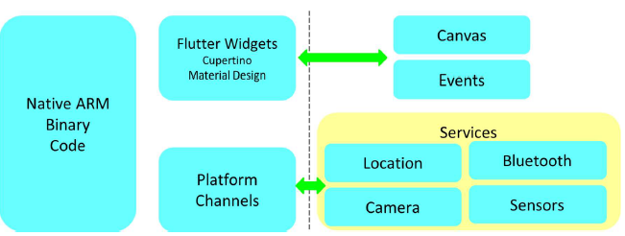
Figure 5. Architecture of Flutter Mobile Application Framework.
    - User Interface Design and Navigation Flow
The user interface flow of the AUMOR mobile application is shown in Figure 6. The sequence begins with the app icon on the device’s home screen (Figure 6 (a)), providing quick access to the system. The panels in Figure 6 (b) and Figure 6 (c) show the login screen, where users are required to input their email and password credentials, respectively. The log-in interface features a clean and minimalistic design, with a password visibility toggle, “forgot password” option, and a sign-up prompt for new users. Once authenticated, users are directed to the main feature menu (fourth panel). The menu contains four core functionalities as shown in Figure 6 (d).
- GPS Guide for navigation and location-based information access on the campus.
- QR Scanner for retrieving contextual information and resources by scanning QR codes placed across the university facilities.
- Quiz which is an interactive feature designed to reinforce orientation knowledge through gamified learning.
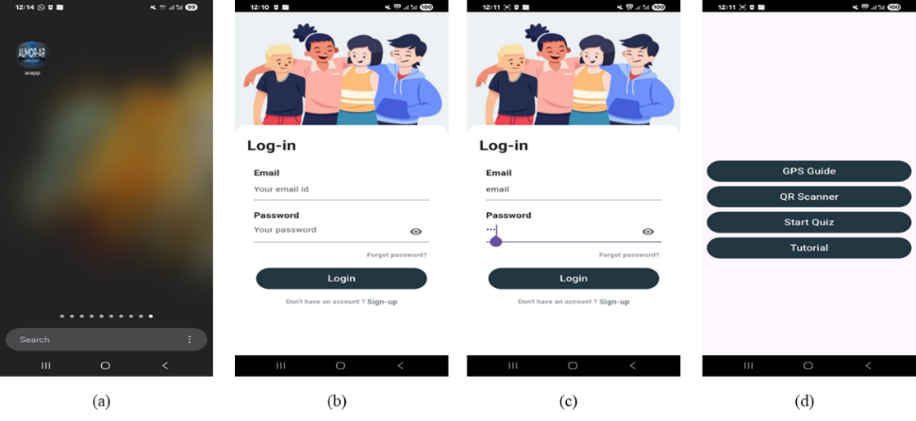
- Tutorial offers demo and instructions to new users, enhancing ease of use and adoption.
Figure 6. User interface flow of the AUMOR application
    - GPS Integration for Location-Based Services
The app uses GPS-based navigation to deliver information when a student approaches a relevant place on campus. When students approach a point of interest such as a building, restaurant, or outdoor venue, the app activates an AR overlay that anchors to the scene and offers context-specific resources including web links, quick videos, maps, downloadable PDFs, and, where appropriate, simple booking actions (e.g., study rooms or event check-ins). The students can see what matters for the spot in their surroundings resulting in reduced search time and help first-time visitors move confidently between locations and find their way. To build this experience, we marked key campus points of interest and recorded their precise coordinates using Google Maps. Each location was added to a lightweight JSON [56] catalog that stored its name, latitude/longitude, and AR contents to show on request as shown in Figure 7(a) and Figure 7(b). In our pilot study, we have included twenty-five locations, each of which is represented by a red dot if they fall within the area under the radar (the geofence). The students can see what is nearby at a glance while content updates remain centrally managed.
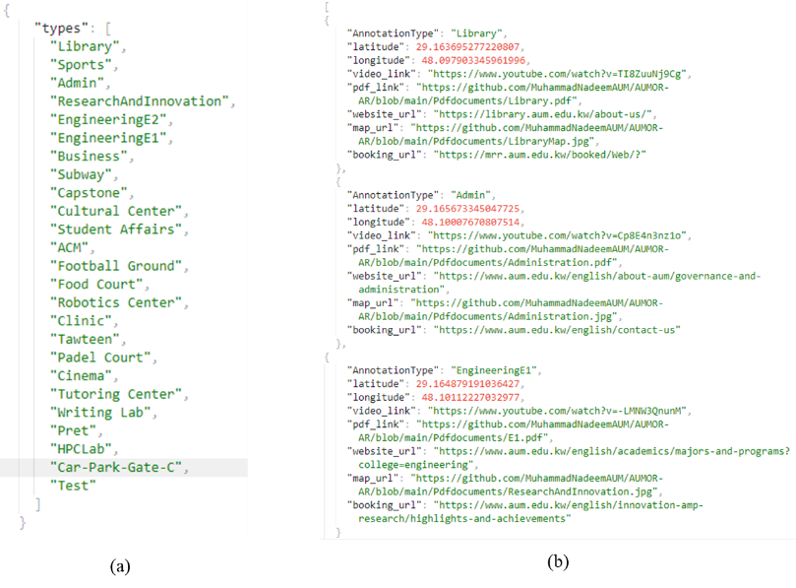
Figure 7. JSON data structure used for annotating campus locations and resources
When a student enters a geofence, the app displays the location name; tapping it opens an AR panel with the available options to select. For example, a student nearing the Administration Building would see a prompt, and upon clicking, assets are streamed from the web to keep the app small, with essential items cached for spotty connectivity. The details of the metadata for the selected annotations, including coordinates, video links, websites, booking links, and related documents, are shown in Figure 7(b). This GPS-plus-AR approach turns the campus into an interactive guide, providing students with timely and trustworthy information as they navigate their orientation.
The screenshots in Figure 8 illustrate the location-based information system of the AUMOR application. In the first panel shown in Figure 8(a), the system overlays a radar-style marker on the real-world environment to identify nearby locations, such as laboratories, classrooms, cafés, and library. Floating labels provide contextual information such as the name of the building or facility and its distance from the user enabling intuitive and location-aware navigations. Multiple markers in Figure 8(b) allow users to see several locations within the range, such as business buildings, computer labs, tutoring centers, and capstone project rooms providing a comprehensive situational overview, reducing the cognitive load required for navigation in unfamiliar environments. The third panel in Figure 8(c) shows the interactive information panel that is triggered when a user selects a location. This panel provides access to rich multimedia resources, including videos, documents, website links, room maps, and booking options. Such features extend the utility of AR beyond navigation, transforming it into an integrated learning and resource platform for orientation and daily campus use.
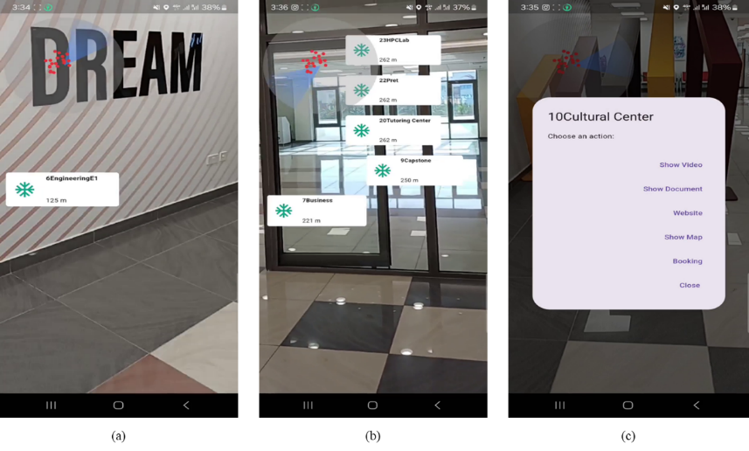
Figure 8. Augmented Reality navigation and resource interface of the AUMOR application
    - QR Code Implementation for Information Retrieval
We paired AR with QR codes placed on the key equipment encoding a resource name in plain text that the app reads with the camera and resolves against a lightweight JSON catalog mapping that text to an up-to-date content bundle. On scan, the app presents these options as an AR overlay (and accessible list view); tapping it opens the selected asset online. The contents are placed at a single repository to keep the app small while allowing centralized updates without reprinting codes. This scan-to-experience flow delivers just-in-time information for students working with diversified equipment in the lab or looking for staff members. Quick access to resources such as documentation and tutorial etc. helps students perform task without difficulty reducing the friction and make learning experience more enjoyable. The list of resource and related AR contents are shown in Figure 9.
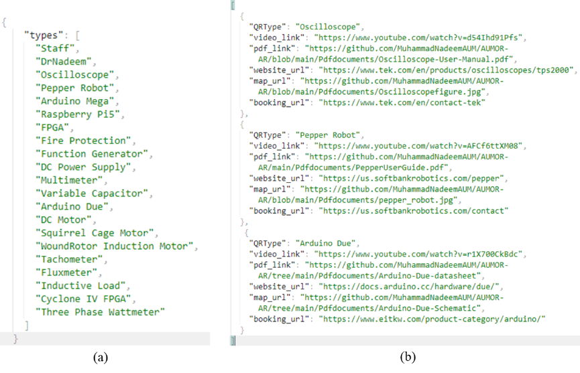
Figure 9. JSON data structure for annotating resources embedded with QR code.

The example QR code enabled information retrieval system designed to facilitate immediate access to technical resources for the Arduino Due board is shown in Figure 10. The QR code is placed on the board packaging ss shown in Figure 10(a), establishing a direct link between the physical hardware and relevant digital resources. When the QR code is scanned, it decoded to plain text and system recognizes the device as “Arduino Due” and presents users with a structured set of contents such video tutorials, datasheets, official website access, schematic drawings, and contact details as shown in Figure 10(b). When users select the required option, website for example, they the redirected to the official Arduino documentation portal, where authoritative materials, such as pinout diagrams, datasheets, circuit schematics, and prototyping files, are provided as shown in Figure 10(c) illustrates. This highlights the pedagogical and practical value of embedding QR codes into engineering education contexts, as it effectively bridges physical components with digital learning environments, promotes self-directed inquiry, and ensures learners’ engagement with current and reliable technical content. This functionality exemplifies how QR technology can support efficient knowledge acquisition by minimizing the cognitive and temporal effort required to locate appropriate resources.
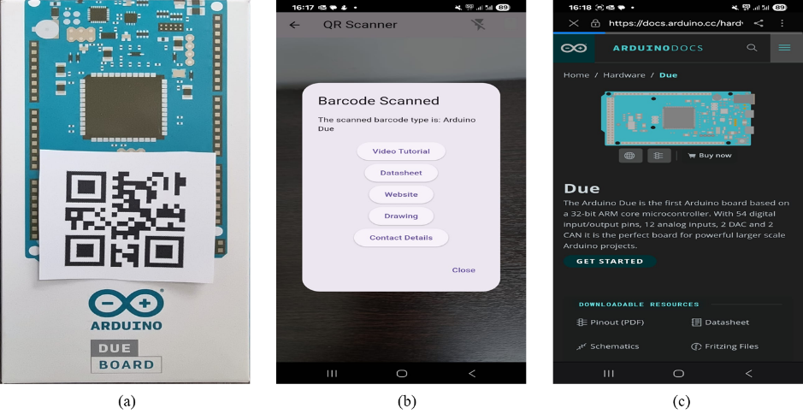
Figure 10. Workflow of QR code–based access to resources for the Arduino Due board.
- Results
In this section, we present the evaluation results of AUMOR application. The app was tested in real-life with screenshots provided in Figure A1 showing navigation (Figure A1 (a) and (b), QR code (Figure A1 (c) and (d)), and quiz (Figure A1 (e) and (f)). The breakdown of results is provided in Table A2 (Appendix A). The data collected were analyzed using R software (version 4.0.3). The internal consistency of the survey was very good, with a Cronbach’s alpha of .928. Broken down by subscale, the internal reliability for all constructs is provided in

Table 2. The low value for AU is expected because the options provided for these questions are distinct features, not parallel items tapping one latent construct.

Table 2. Reliability of constructs based on Cronbach’s alpha.
Construct | Items | Cronbach’s α
Perceived Usefulness (PU) | Q5 - Q9 | 0.837
Perceived Ease of Use (PEOU) | Q10 - Q15 | 0.734
Attention to Use (ATU) | Q16 – Q19 | 0.822
Behavioral Intention to Use (BIU) | Q20 – Q22 | 0.828
Actual Use (AU) | Q23 – Q25 | 0.521
The correlation coefficients and their statistical significance (p-values) for all hypotheses are provided in Table 3. It can be seen that all the relationships are positive and statistically significant (p < 0.001), meaning there is strong evidence supporting each hypothesized path in the TAM model. The strongest effect is ATU → BIU (r = 0.803), showing that attitude toward use is the most influential factor in shaping behavioral intention. The lowest but still significant is PEOU → PU (r = 0.499), suggesting that perceived ease of use moderately enhances perceived usefulness.
Table 3. Correlation analysis of hypothesis.
Hypothesis | Relationship | Correlation | p-value | Interpretation
H1 | PEOU → PU | 0.499 | < 0.001 | Moderate positive correlation
H2 | PU → ATU | 0.619 | < 0.001 | Strong positive correlation
H3 | PEOU → ATU | 0.758 | < 0.001 | Strong positive correlation
H4 | ATU → BIU | 0.803 | < 0.001 | Very strong positive correlation
H5 | PU → BIU | 0.678 | < 0.001 | Strong positive correlation
H6 | BIU → AU | 0.665 | < 0.001 | Strong positive correlation
The total number of participants was 128, comprising 39.84% males and 60.16% females, with their current academic levels reported in Table 4 below. Most participants were junior (36.72%) or sophomore (31.25 %) students.
Table 4. Participant demographics
Characteristics | Attributes |  |  |  |  |  |  | Total
Participant Gender | Male (51) |  |  |  | Female (77) |  |  | 128
Participant Gender | 39.84% |  |  |  | 60.16% |  |  | 100%
Participant Age (Years) | Freshmen | Sophomore | Junior | Senior |  | Faculty | Staff | 128
Participant Age (Years) | 12.50% (16) | 31.25% (40) | 63.72% (47) | 15.63% (20) |  | 3.13% (4) | 0.78% (1) | 100%
Approximately one-third of the participants (32.81%, n=42) reported using mobile applications for educational purposes often, and over a third (35.15%, n=45) said they sometimes did so and only a small minority reported minimal engagement, with 4.69% using them rarely and 1.56% never using them. Regarding familiarity with AR, most respondents (57.03%, n=73) have not used an AR app before, while 40.63% (n=52) reported prior AR use, and 2.34% (n=3) did not answer. This means that the proposed AR app is new to many students, which helps explain the sizable neutral responses in ease-of-use/usefulness items; many are first-time users still forming opinions.
The breakdown of the perceived usefulness (PU) of the application is shown in Figure 11. Most of the students found the AUMOR was useful for understanding the university campus layout (60.16%, n=77), finding useful information about campus facilities (75%, n=96), and overall orientation experience (57.82%, n=74). For most participants (74.22%, n=95), using the AR app saved time in finding important campus locations, and it helped with confident campus navigation (57.03%, n=73).
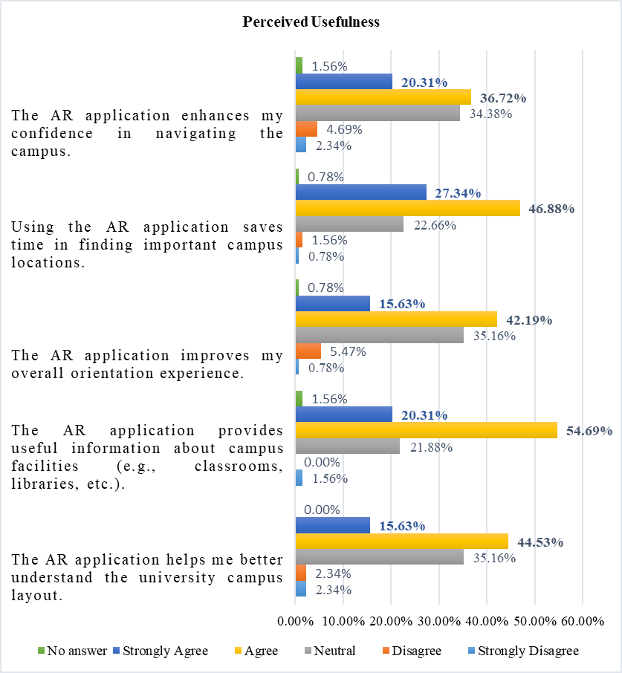
Figure 11. Breakdown of perceived usefulness of the AR application.
Figure 12 shows a breakdown of the perceived ease of use (PEOU) and most of the survey participants found information about different campus locations easily using the application (71.88%, n=92). They also found the AUMOR app simple to learn and use (70.32%, n=90) and did not require additional instructions to understand how to use the application (49.22%, n=63). The AR app was quick to respond according to 54.68% (n=70) of the survey participants, with a user-friendly layout and design (66.41%, n=85), and it was not difficult to use (52.35%, n=67).
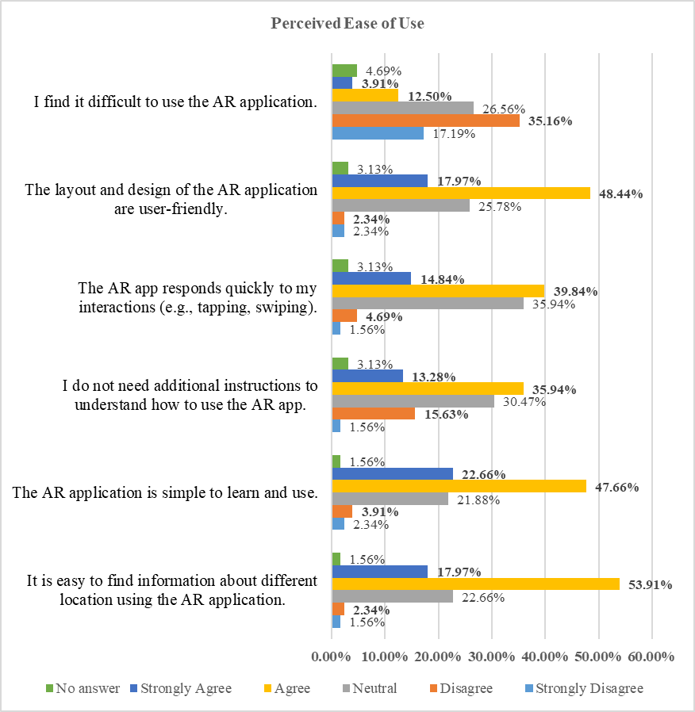
Figure 12. Breakdown of the perceived ease of use of AR application.
The ATU results were broadly positive Figure 13. Students most strongly endorsed the concept, with 75.79% (n=97) believing that using the AUMOR app for orientation was a good idea, with only 2.34% (n=3) disagreeing and 18.75% (n=24) neutral. They also found it engaging, as 71.10% (SA+A, n=31) said that the app was a fun way to explore the campus, while only 8.59% disagreed and 17.19% were neutral. Personal experience was solid but mixed with 58.60% (n=75) feeling confident when navigating the app, while 30.47% (n=39) were neutral and only 7.04% disagreed. Similarly, 53.91% (SA+A, n=69) enjoyed using it during orientation, with a relatively high 35.94% (n=46) neutral and 6.25% (n=8) negative responses. Non-responses were small (3% for each item). In short, students buy into the idea and fun of AR, but a sizeable neutral block on confidence and enjoyment suggests room for improvement to convert the undecided into enthusiastic users.
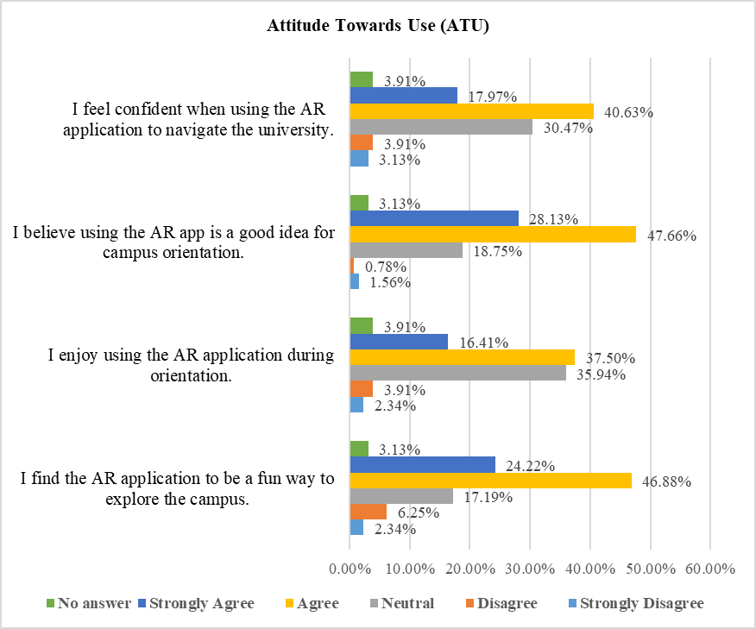
Figure 13. Breakdown of attitude towards the use of the AR application.
The Behavioral Intention to Use (BIU) results shown in Figure 14 are strong overall as 75.0% (n=96) would recommend the AR app to other students, with only 7.03% (n=9) negative and 14.84% (n=19) neutral. Preference over traditional orientation methods were positive but more mixed with 53.9% (n=69) favoring the AR approach, while 29.69% (n=38) are neutral and 11.72% (n=15) disagree, suggesting many are open to AR but still comparing it with familiar formats. The intent to continue using the app during university was similarly moderate with 52.35% positive (SA+A, n=67)), 32.81% (n=42) neutral, and 10.16% (n=13) negative.
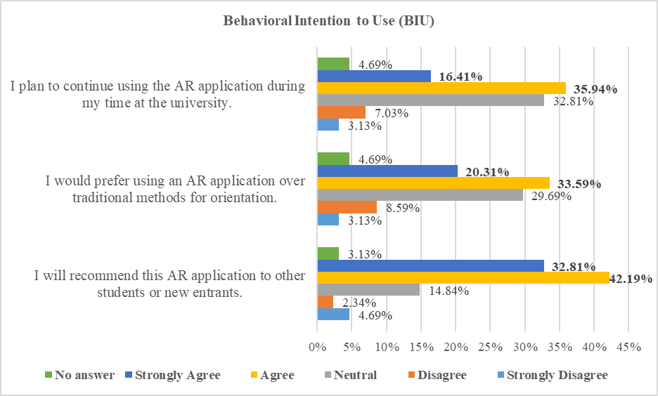
Figure 14. Breakdown of the behavioral intention to use AR application.
The breakdown of the usage of the different features of the AUMOR application is presented in Figure 15. We observed that the survey participants used the app mainly for campus navigation (51.56%, n=66) and for finding information about laboratory equipment (39.06%, n=50). Approximately one-third of the participants used the AR app to locate specific buildings or departments (29.69%, n=38), gather information on student services (28.91%, n=37), and access event schedules (27.34%, n=35). Some participants were also interested in virtual campus tours (18.75%, N=24).
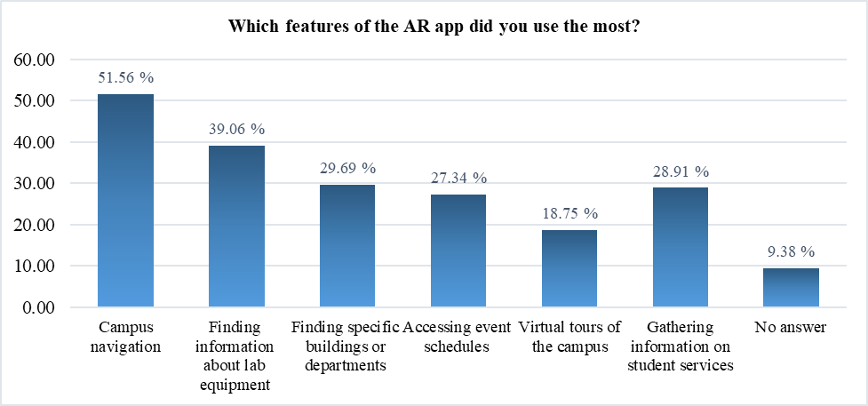
Figure 15. Breakdown of the usage of the different features of the AR application.
Figure 16 shows the intended use of the AR application after orientation. Most of the survey participants were likely or very likely to continue using the AR application after the orientation (57.03% of the total).
We performed an inductive thematic analysis to the open-ended item “What kind of information would you like to see on the application?” We also performed an inductive thematic analysis to the second open-ended item “What will you suggest improving this application?” The responses were multi-coded, total exceeding 100% and outcomes are as follows.
- Real-time status, Live status features
- Content expansions (Academic info and student services, hours, booking of utilities, events and schedules)
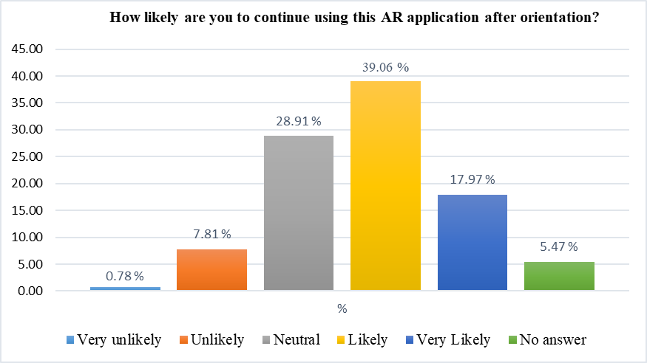
Figure 16. Intended usage of the AR application after the orientation
- Navigation and wayfinding
- iOS availability
- Application features (simplified UI/US, performance, reliability & accuracy)
- Discussion
The evaluation results presented in previous section confirm the potential of augmented reality combined with GPS and QR code technologies to improve the orientation experience of new students. PU received highest rating in terms of timesaving and facility information, reflecting that application successfully provides access to contextual information instantly at the point of need. This is compatible with earlier findings which suggest that mobile applications are valuable when they reduce effort and provide ease in performing real-world tasks. However, low scores for confidence in navigation and improvement in overall orientation experience were more moderate. This suggests that the application delivers the information but does not offer complete way finding solution for visitors.
The PEU results were similarly promising finding the application simple to learn, intuitive for accessing information, and has user-friendly layout. These findings align with the core principles of the TAM, which emphasizes that PEU is a key factor that influences the user acceptance and sustained engagement with technology [50]. Many other studies suggest that ease of use significantly predicts BI and AU, especially in educational technology contexts [12], [57]. Specifically, in AR-based learning environments, students who perceive systems as easier to navigate are more likely to develop positive attitudes and trust in the system [57]. Relatively weaker scores in system responsiveness and the expressed need for support indicate the areas needing the improvement. These concerns are coherent with outcomes of earlier research that emphasize the importance of system responsiveness and structured onboarding in AR applications to reduce cognitive load and anxiety [58], [59]. Since students were not familiar with AR technologies, the integration of improved tutorials could increase user because structured support materials and smooth interface feedback loops bridge initial resistance and improve the perceived ease of use [60], [61]. Furthermore, poor internet quality due the surrounding building might also contribute to the low scores to the system responsiveness. This could be overcome by making the contents available offline by embedding them in the application thus improving the response time of the system by removing dependence on internet and eliminating the request and response time altogether. But it comes at the cost as it can significantly increases the size of the application. Furthermore, it will result in loss of flexibility and efficiency as it will not be possible to update or modify the content centrally. A recompilation of the application by developer and update on mobile from the user will be needed as a result of any change in the content.
The results regarding attitude towards use show strong endorsement of AUMOR as nearly three-quarters of respondents favoured that using the app was a good idea for orientation, and a fun way to explore campus. These findings highlight that students view AR as functional and enjoyable, supporting the premise that perceived enjoyment can reinforce acceptance, as noted in the extended versions of the Technology Acceptance Model 3 (TAM3). However, indicators of confidence and personal enjoyment were somewhat lower with a sizable proportion of neutral responses suggesting that some students remain cautious or undecided about its reliability and personal value for practical use. Such hesitation is often linked to first-time exposure to AR technologies, as many of the participants never used AR before. Another reason for the low score can be the contribution of the senior students who have spent a lot of time at the university and do not perceive it the same way as the freshmen. This can be improved by including micro-onboarding, optimizing the performance to reduce lag, and improving indoor navigation accuracy. These measures can change neutral attitudes into more enthusiastic adoption, maximizing the impact of AUMOR.
The outcomes of behavioural intention were similarly promising as most of the students reported that they will recommend the AR app to their peers, demonstrating a strong potential. More than half of the students expressed a preference for AR-based orientation over traditional methods and have the intentions to use it during their studies. These results suggest that AUMOR has a clear pathway for sustained adoption, provided that its reliability and relevance continue to improve. But a large number of students were for both preference and continued which requires improvements so that it could be more beneficial students’ daily academic lives. Inclusion of extra feature such as real-time event reminders, updates on facilities, and academic service integration (grades, office hours) could embed the app into routine student practice. Aligning AR content with students’ immediate academic and administrative needs may transform the app from a one-time orientation aid to a long-term companion throughout their university journey. In line with TAM, the BIU findings underscore that positive attitudes and perceived usefulness drive the intention to use. By taking advantage of on high recommendation rates and addressing areas of concerns, universities can ensure that AUMOR become an integral part of the student experience, rather than a novelty used only at the start of the academic year.
The analysis of student feedback highlighted five major domains of desired mobile application features for enhancing the campus experience. Real-time status and availability information was the most emphasized with students requesting live updates on parking status, building occupancy, cafeteria menus, and utilities such as power or air conditioning status. These are crucial because they eat up a lot time while looking for parking or waiting in queues to buy something from cafeteria. These features reflect the increasing demand for improved mobility and decision-making in real time [62].
“Available parking; subway is crowded or not”; “real time cafeteria menus”;
The content expansions was another theme calling for more comprehensive coverage of office locations, hours, semester dates, and class times as apparent from the following remarks from the students:
“Access to information about events happening at AUM”; “reminders about assignments and events”
“Quick information about the office hours of faculty, information about course projects”
“Booking of study rooming library”; “booking of seminars and workshops”
“FAQ section for new students”; “updated semester schedule”
Such expansions align with research showing that information-rich applications increase perceived usefulness and institutional trust [63]. Inclusion of features such as centralized access to event dates, semester-specific schedules, and integrated reminder about functions, aligning with prior findings that calendar-linked notifications significantly improve student engagement [64]. Meanwhile, booking and utilities (~7%) focused on study room reservations and workshop/lab bookings, functions that are increasingly integrated into smart campus platforms [35]. The students also expressed profound interest in getting academic information and student services, including grades, assessment feedback, project updates, and faculty office hours [71]. This resonates with previous research indicating that academic transparency and immediate access to information strongly influence students’ satisfaction with learning technologies [65]. The availability of office hours is important for students as it is helpful to get personalized help from the teacher, get feedback, and build strong relationships. But integration of academic information such as the student grades as it is not feasible due to sensitivity of the data and may face risk of security as it is highly confidential. Therefore, students need to access this information through official portal. Finally, help, and usability (approx. 12%) were cited, including requests for clearer information, full campus guides, and FAQ sections, which were particularly valuable for first-year students adapting to a new academic environment [63]. These facilities are particularly in demand when an assessment is due.
Navigation and wayfinding were another prominent need (~25–30%) as mentioned by students in their responses:
“Campus navigation”; “clicking on class should show me the way”; “places of every building”
In large university campuses, students often run from one class to another class in their busy schedule. Navigating through unfamiliar places puts an extra pressure on us to go to wrong places and miss the class. where students envisioned location-aware routing linked directly to their class schedules, echoing evidence that location-based services improve campus accessibility and efficiency [66], [67]. Although finding solutions are provided in this application but a more direct or map based approach is more appreciated by the students.
Performance, reliability, accuracy, UI/UX simplification, and modernization (approx. 25%) were also highlighted, with students demanding faster load times, bug fixes, and more precise locations and AR features. The students requested clearer layouts, organized lists, and more interactive designs. This is clear from student responses given below:
“Quicker response, quicker updates”, “give precise locations”,
Research on learning technologies confirms that well-structured and aesthetically modernized interfaces reduce cognitive load and increase user engagement [68]. The main reason for delayed response is the quality of internet service, which might vary depending on the location and the services provider4e. Also, the GPS service is not precise at some time due to signal blockage, multipath interference, and atmospheric conditions. Prior studies have similarly shown that system responsiveness and reliability are critical determinants of user satisfaction and continued use of educational apps [69]. The GPS precision can be maximized by turning power saving mode and enabling high accuracy and keeping the software up to date.
iOS availability and distribution emerged as the most frequently mentioned (approx. 35%), with students requesting that the app be made accessible via the Apple App Store to support iPhone users as evident from the following student comments:
“Upload it in the Apple…”, “make it for iOS”, “allow iPhone users to download it”
This aligns with broader evidence showing that cross-platform compatibility significantly increases adoption and inclusivity in mobile applications for higher education [70]. The demand basically stems from the fact that most of the students possess Apple phone. Although iOS apps are secure and provide enhanced user experience, but stringent App Store leads to longer approval times and also offer limited customization at the same time. The availability of the cheap Android phones and open source development platforms were main reason behind its selection as the target platforms.
One of the main strengths of this application is the integration of GPS and QR code scanning with AR overlays, which provide students with information immediately at the point of need. This design was appreciated for its ability to reduce the time spent searching for facilities and resources, which aligns well with the goals of orientation programs. Its incremental development model also allows for iterative improvements and scalability. From maintenance point of few, the contents delivered can be modified and updated without the need for recompilation making housekeeping of the application easy. However, it also suffers from some weaknesses as basic navigation has limited value for students, especially the senior students who were already familiar with the campus. Moreover, lag in AR responsiveness and lack of precision on some occasions in location detection, reduce user confidence. Accessibility gaps were also highlighted, especially the lack of iOS compatibility, which was one of the most common suggestions for improvement by the participants. These weaknesses confirm the findings of previous AR campus systems, which frequently encountered barriers related to technical stability, inclusivity, and scalability [72]. AUMOR also supports SDG 4 (Quality Education), which emphasizes inclusive and equitable access to lifelong learning [73].
AUMOR offers several advantages when compared with earlier AR-based orientation initiatives applications. Early systems, such as those at Columbia University and Fu-Jen Catholic University, focused on head-mounted displays or AR visualization of campus landmarks thus require specialized hardware and offered limited scalability. More recently, Chung Hua University and the University of Quindío have used multimedia and 3D directional boards, but they lack GPS precision and QR code versatility. AUMOR’s hybrid approach, on the other hand, uses smartphone with both GPS and QR-triggered AR overlays successful achieving stronger accessibility and reducing the dependence on expensive hardware. Furthermore, AUMOR’s evaluation of 128 participants adds to the literature by providing a large-scale, empirical dataset. While studies at universities such as Bowling Green State or Haaga-Helia UAS focused on niche features (cultural exploration or missed orientation catch-up), AUMOR demonstrates the feasibility of embedding AR into mainstream orientation practices in higher education. Its integration of TAM as an evaluative framework also provides a theoretical contribution, bridging technology adoption theory with situated learning perspectives in the university orientation context.
AUMOR complements or substitute traditional orientation programs which are often resource-intensive and costly. Second, the open-ended feedback from students underscores the demand for richer real-time functionality, including live updates on parking and event as well as integration with academic services. Incorporating these features would extend the use beyond orientation into everyday life of a student fostering a long-term engagement. Alos, the results reinforce that technology adoption not only depends on novel features but also on reliability, inclusivity, and relevance. Therefore, addressing performance stability, expanding platform availability, and layering personalized academic content are critical steps for boosting the impact.
- Conclusion
This study presents the design, implementation, and evaluation of the AR-based mobile to support student orientation through the integration of GPS, and QR code technologies. This application addresses the common challenges faced by the students who feel disoriented and time-pressed in large universities by providing location-based information as well as information about the equipment when performing experiments in the lab. The evaluation results indicated that students found the system useful for saving time and accessing facility information due to its clean design and simple interface contributing to their perceptions of ease of use. The interactive features, such as floating labels, multimedia resources, and quizzes, highlight engagement and learning potential of the application. The research contributes to the field of educational technology, advancing understanding of AR-assisted learning environments and technology adoption (TAM) in higher education. The findings suggest that student services offices can integrating AR applications into orientation activities to provide interactive experiences that promote engagement. Despite its strengths, the areas for improvement include the need for performance optimization, cross-platform availability (iOS compatibility), and personalized content delivery. Compared with previous AR-based orientation systems, AUMOR advances the field by combining affordability, scalability, and empirical validation in a real-world context. Future work should focus on improving the application with real-time event updates, academic service integration, and accessibility options to support diverse student populations. The AUMOR has the potential to evolve into a comprehensive digital campus companion improved student engagement, time management, and well-being of students.
Author Contributions: Conceptualization, M.N. and M.O.; methodology, M.N., M.O., P.A., and H.O.; software, M.N., M.O., and P.A.; validation, M.N., M.O., P.A., and H.O., and S.B.; formal analysis, M.N., M.O., and P.A.; investigation, M.N., M.O., P.A., and H.O., and S.B.; resources, M.N., M.O., and H.O.; data curation, P.A., and H.O.; writing—original draft preparation, M.N., M.O., P.A., H.O., and S.B.; writing—editing and review, M.N., M.O., P.A., H.O., and S.B.; visualization, M.N., M.O., P.A., H.O., and S.B.; supervision, M.N. and M.O.; project administration, M.N; All authors have read and agreed to the published version of the manuscript.”
Funding: This research received no external funding
Data Availability Statement: Data available on request.
Conflicts of Interest: The authors declare no conflicts of interest.
Appendix A:
Table A1. Questionnaire Used in User Testing
Section 1: Participant Demographics | Q1 | Gender
Section 1: Participant Demographics | Q2 | Current Academic Level
Section 1: Participant Demographics | Q3 | How often do you use mobile applications for educational purposes?
Section 1: Participant Demographics | Q4 | Have you used an AR-based application before?
Section 2: Perceived Usefulness | Q5 | The AR application helps me better understand the university campus layout.
Section 2: Perceived Usefulness | Q6 | The AR application provides useful information about campus facilities
Section 2: Perceived Usefulness | Q7 | The AR application improves my overall orientation experience.
Section 2: Perceived Usefulness | Q8 | Using the AR application saves time in finding important campus locations.
Section 2: Perceived Usefulness | Q9 | The AR application enhances my confidence in navigating the campus.
Section 3: Perceived Ease of Use | Q10 | It is easy to find information about different locations using the AR application.
Section 3: Perceived Ease of Use | Q11 | The AR application is simple to learn and use.
Section 3: Perceived Ease of Use | Q12 | I do not need additional instructions to understand how to use the AR app.
Section 3: Perceived Ease of Use | Q13 | The AR app responds quickly to my interactions (e.g., tapping, swiping).
Section 3: Perceived Ease of Use | Q14 | The layout and design of the AR application are user-friendly.
Section 3: Perceived Ease of Use | Q15 | I find it difficult to use the AR application.
Section 4: Attitude Towards Use - ATU | Q16 | I find the AR application to be a fun way to explore the campus.
Section 4: Attitude Towards Use - ATU | Q17 | I enjoy using the AR application during orientation.
Section 4: Attitude Towards Use - ATU | Q18 | I believe using the AR app is a good idea for campus orientation.
Section 4: Attitude Towards Use - ATU | Q19 | I feel confident when using the AR application to navigate the university.
Section 5: Behavioral Intention to Use – BIU | Q20 | I will recommend this AR application to other students or new entrants.
Section 5: Behavioral Intention to Use – BIU | Q21 | I would prefer using an AR application over traditional methods for orientation.
Section 5: Behavioral Intention to Use – BIU | Q22 | I plan to continue using the AR application during my time at the university.
Section 6: Actual Use – AU | Q23 | Which features of the AR app did you use the most? (Select all that apply)
Section 6: Actual Use – AU | Q24 | How frequently did you use the AR application during your orientation?
Section 6: Actual Use – AU | Q25 | How likely are you to continue using this AR application after orientation?
Section 7: Open-Ended | Q26 | What kind of information would you like to see on the application?
Section 7: Open-Ended | Q27 | What will you suggest improving this application?

Table A2. Breakdown of responses
Q# | Response | Female | Male | Freshman | Sophomore | Junior | Senior | Faculty | Staff
Q2 | Never | 50.00% (1) | 50.00% (1) | 0.00% (0) | 50.00% (1) | 50.00% (1) | 0.00%(0) | 0.00%(0) | 0.00% (0)
Q2 | Often | 64.29%(27) | 35.71%(15) | 7.14% (3) | 33.33%(14) | 47.62%(20) | 9.52%(4) | 2.38%(1) | 0.00% (0)
Q3 | Rarely | 33.33% (2) | 66.67% (4) | 16.67% (1) | 50.00% (3) | 16.67% (1) | 16.67%(1) | 0.00%(0) | 0.00%(0)
Q3 | Sometimes | 52.17%(24) | 47.83% (22) | 17.39% (8) | 32.61% (15) | 30.43% (14) | 15.22%(7) | 4.35%(2) | 0.00% (0)
Q3 | Often | 71.88%(23) | 28.12% (9) | 12.50% (4) | 21.88% (7) | 34.38% (11) | 25.00% (8) | 3.12% (1) | 3.12% (1)
Q4 | - | 66.67% (2) | 33.33% (1) | 0.00% (0) | 66.67% (2) | 33.33% (1) | 0.00% (0) | 0.00%(0) | 0.00%(0)
Q4 | No | 67.12%(49) | 32.88% (24) | 8.22% (6) | 30.14% (22) | 41.10% (30) | 17.81%(13) | 2.74%(2) | 0.00%(0)
Q4 | Yes | 50.00%(26) | 50.00% (26) | 19.23%(10) | 30.77% (16) | 30.77% (16) | 13.46% (7) | 3.85%(2) | 1.92%(1)
Q5 | SA | 70.00%(14) | 30.00% (6) | 15.00% (3) | 15.00% (3) | 40.00% (8) | 15.00% (3) | 10.00%(2) | 5.00% (1)
Q5 | A | 57.89%(33) | 42.11% (24) | 10.53% (6) | 31.58% (18) | 42.11% (24) | 14.04% (8) | 1.75% (1) | 0.00% (0)
Q5 | N | 57.78%(26) | 42.22% (19) | 15.56% (7) | 40.00% (18) | 26.67% (12) | 17.78% (8) | 0.00% (0) | 0.00% (0)
Q5 | DA | 66.67% (2) | 33.33% (1) | 0.00% (0) | 0.00% (0) | 33.33% (1) | 33.33% (1) | 33.33%(1) | 0.00% (0)
Q5 | SDA | 66.67% (2) | 33.33% (1) | 0.00% (0) | 33.33% (1) | 66.67% (2) | 0.00% (0) | 0.00% (0) | 0.00% (0)
Q5 | NA | - | - | - | - | - | - | - | -
Q6 | SA | 69.23%(18) | 30.77%(8) | 11.54% (3) | 23.08% (6) | 42.31% (11) | 15.38% (4) | 3.85% (1) | 3.85% (1)
Q6 | A | 55.71%(39) | 44.29% (31) | 14.29%(10) | 28.57% (20) | 40.00% (28) | 14.29%(10) | 2.86% (2) | 0.00% (0)
Q6 | N | 60.71%(17) | 39.29% (11) | 10.71% (3) | 42.86% (12) | 21.43% (6) | 21.43% (6) | 3.57% (1) | 0.00% (0)
Q6 | DA
Q6 | SDA | 50.00% (1) | 50.00% (1) | 0.00% (0) | 50.00% (1) | 50.00% (1) | 0.00% (0) | 0.00% (0) | 0.00% (0)
Q6 | NA | 100.00%(2) | 0.00% (0) | 0.00% (0) | 50.00% (1) | 50.00% (1) | 0.00% (0) | 0.00% (0) | 0.00% (0)
Q7 | SA | 70.00%(14) | 30.00% (6) | 10.00% (2) | 15.00% (3) | 40.00% (8) | 25.00% (5) | 5.00% (1) | 5.00% (1)
Q7 | A | 74.07%(40) | 25.93% (14) | 9.26% (5) | 22.22% (12) | 53.70% (29) | 11.11% (6) | 3.70% (2) | 0.00% (0)
Q7 | N | 37.78%(17) | 62.22% (28) | 17.78% (8) | 46.67% (21) | 20.00% (9) | 15.56% (7) | 0.00% (0) | 0.00% (0)
Q7 | DA | 57.14% (4) | 42.86% (3) | 14.29% (1) | 42.86% (3) | 0.00% (0) | 28.57% (2) | 14.29%(1) | 0.00% (0)
Q7 | SDA | 100.00%(1) | 0.00% (0) | 0.00% (0) | 0.00% (0) | 100.00% (1) | 0.00% (0) | 0.00% (0) | 0.00% (0)
Q7 | NA | 100.00%(1) | 0.00% (0) | 0.00% (0) | 100.00% (1) | 0.00% (0) | 0.00% (0) | 0.00% (0) | 0.00% (0)
Q8 | SA | 54.29%(19) | 45.71% (16) | 20.00% (7) | 28.57% (10) | 25.71% (9) | 20.00% (7) | 2.86% (1) | 2.86% (1)
Q8 | A | 68.33%(41) | 31.67% (19) | 5.00% (3) | 33.33% (20) | 51.67% (31) | 6.67% (4) | 3.33% (2) | 0.00% (0)
Q8 | N | 44.83%(13) | 55.17% (16) | 20.69% (6) | 27.59% (8) | 20.69% (6) | 27.59% (8) | 3.45% (1) | 0.00% (0)
Q8 | DA | 100.00%(2) | 0.00% (0) | 0.00% (0) | 50.00% (1) | 0.00% (0) | 50.00% (1) | 0.00% (0) | 0.00% (0)
Q8 | SDA | 100.00%(1) | 0.00% (0) | 0.00% (0) | 0.00% (0) | 100.00% (1) | 0.00%(0) | 0.00% (0) | 0.00% (0)
Q8 | NA | 100.00%(1) | 0.00% (0) | 0.00% (0) | 100.00% (1) | 0.00% (0) | 0.00% (0) | 0.00% (0) | 0.00% (0)
Q9 | SA | 65.38% 17) | 34.62% (9) | 15.38% (4) | 19.23% (5) | 42.31% (11) | 19.23% (5) | 3.85% (1) | 0.00% (0)
Q9 | A | 68.09%(32) | 31.91% (15) | 10.64% (5) | 34.04% (16) | 38.30% (18) | 12.77% (6) | 2.13% (1) | 2.13% (1)
Q9 | N | 50.00% 22) | 50.00% (22) | 13.64% (6) | 36.36% (16) | 31.82% (14) | 18.18% (8) | 0.00% (0) | 0.00% (0)
Q9 | DA | 33.33% (2) | 66.67% (4) | 0.00% (0) | 16.67% (1) | 33.33% (2) | 16.67% (1) | 33.33%(2) | 0.00% (0)
Q9 | SDA | 100.00%(3) | 0.00% (0) | 0.00% (0) | 33.33% (1) | 66.67% (2) | 0.00% (0) | 0.00% (0) | 0.00% (0)
Q9 | NA | 50.00% (1) | 50.00% (1) | 50.00% (1) | 50.00% (1) | 0.00% (0) | 0.00% (0) | 0.00% (0) | 0.00% (0)
Q10 | SA | 60.87%(14) | 39.13% (9) | 17.39% (4) | 30.43% (7) | 34.78% (8) | 13.04% (3) | 4.35% (1) | 0.00% (0)
Q10 | A | 63.77%(44) | 36.23% (25) | 11.59% (8) | 30.43% (21) | 44.93% (31) | 10.14% (7) | 1.45% (1) | 1.45% (1)
Q10 | N | 51.72%(15) | 48.28% (14) | 13.79% (4) | 34.48% (10) | 20.69% (6) | 27.59% (8) | 3.45% (1) | 0.00% (0)
Q10 | DA | 33.33% (1) | 66.67% (2) | 0.00% (0) | 33.33% (1) | 33.33% (1) | 0.00% (0) | 33.33%(1) | 0.00% (0)
Q10 | SDA | 50.00% (1) | 50.00% (1) | 0.00% (0) | 0.00% (0) | 50.00% (1) | 50.00% (1) | 0.00% (0) | 0.00% (0)
Q10 | NA | 100.00%(2) | 0.00% (0) | 0.00% (0) | 50.00% (1) | 0.00% (0) | 50.00%(1) | 0.00% (0) | 0.00% (0)
Q11 | SA | 68.97%(20) | 31.03% (9) | 20.69% (6) | 24.14% (7) | 37.93% (11) | 6.90% (2) | 6.90% (2) | 3.45% (1)
Q11 | A | 60.66%(37) | 39.34%(24) | 8.20% (5) | 31.15% (19) | 44.26% (27) | 13.11%(8) | 3.28% (2) | 0.00% (0)
Q11 | N | 50.00%(14) | 50.00% (14) | 17.86%(5) | 32.14% (9) | 28.57% (8) | 21.43% (6) | 0.00% (0) | 0.00% (0)
Q11 | DA | 60.00% (3) | 40.00% (2) | 0.00% (0) | 80.00% (4) | 0.00% (0) | 20.00% (1) | 0.00% (0) | 0.00% (0)
Q11 | SDA | 33.33%(1) | 66.67% (2) | 0.00% (0) | 0.00% (0) | 33.33% (1) | 66.67% (2) | 0.00% (0) | 0.00% (0)
Q11 | NA | 100.00%(2) | 0.00% (0) | 0.00% (0) | 50.00% (1) | 0.00% (0) | 50.00% (1) | 0.00% (0) | 0.00% (0)
Q12 | SA | 64.71%(11) | 35.29% (6) | 17.65% (3) | 41.18% (7) | 29.41% (5) | 0.00% (0) | 5.88% (1) | 5.88% (1)
Q12 | A | 54.35%(25) | 45.65% (21) | 17.39% (8) | 32.61% (15) | 34.78% (16) | 10.87% (5) | 4.35% (2) | 0.00% (0)
Q12 | N | 64.10%(25) | 35.90% (14) | 5.13% (2) | 17.95% (7) | 41.03% (16) | 33.33% 13) | 2.56% (1) | 0.00% (0)
Q12 | DA | 55.00%(11) | 45.00% (9) | 15.00%(3) | 45.00% (9) | 40.00% (8) | 0.00% (0) | 0.00% (0) | 0.00% (0)
Q12 | SDA | 50.00% (1) | 50.00% (1) | 0.00% (0) | 0.00% (0) | 50.00% (1) | 50.00% (1) | 0.00% (0) | 0.00% (0)
Q12 | NA | 100.00%(4) | 0.00% (0) | 0.00% (0) | 50.00% (2) | 25.00% (1) | 25.00% (1) | 0.00% (0) | 0.00% (0)
Q13 | SA | 63.16%(12) | 36.84% (7) | 10.53% (2) | 21.05% (4) | 47.37% (9) | 10.53% (2) | 10.53%(2) | 0.00% (0)
Q13 | A | 70.59%(36) | 29.41% (15) | 17.65% (9) | 25.49% (13) | 43.14%(22) | 9.80%(5) | 1.96% (1) | 1.96% (1)
Q13 | N | 47.83%(22) | 52.17% (24) | 8.70% (4) | 45.65% (21) | 26.09% (12) | 19.57% (9) | 0.00% (0) | 0.00% (0)
Q13 | DA | 33.33% (2) | 66.67% (4) | 16.67% (1) | 0.00% (0) | 50.00%(3) | 16.67% (1) | 16.67%(1) | 0.00% (0)
Q13 | SDA | 50.00% (1) | 50.00% (1) | 0.00%(0) | 0.00% (0) | 50.00%(1) | 50.00% (1) | 0.00% (0) | 0.00% (0)
Q13 | NA | 100.00%(4) | 0.00% (0) | 0.00% (0) | 50.00% (2) | 0.00%(0) | 50.00% (2) | 0.00% (0) | 0.00% (0)
Q14 | SA | 86.96%(20) | 13.04% (3) | 8.70% (2) | 34.78% (8) | 47.83% (11) | 8.70% (2) | 0.00% (0) | 0.00% (0)
Q14 | A | 56.45%(35) | 43.55% (27) | 11.29% (7) | 27.42% (17) | 38.71% (24) | 14.52% (9) | 6.45% (4) | 1.61% (1)
Q14 | N | 48.48%(16) | 51.52% (17) | 18.18% (6) | 33.33% (11) | 30.30% (10) | 18.18%(6) | 0.00% (0) | 0.00% (0)
Q14 | DA | 33.33% (1) | 66.67% (2) | 0.00% (0) | 33.33% (1) | 33.33% (1) | 33.33% (1) | 0.00% (0) | 0.00% (0)
Q14 | SDA | 33.33%(1) | 66.67% (2) | 33.33% (1) | 0.00% (0) | 33.33% (1) | 33.33% (1) | 0.00% (0) | 0.00% (0)
Q14 | NA | 100.00%(4) | 0.00% (0) | 0.00% (0) | 75.00% (3) | 0.00% (0) | 25.00% (1) | 0.00% (0) | 0.00% (0)
Q15 | SA | 20.00% (1) | 80.00% (4) | 20.00% (1) | 20.00% (1) | 60.00% (3) | 0.00% (0) | 0.00% (0) | 0.00% (0)
Q15 | A | 50.00% (8) | 50.00% (8) | 31.25% (5) | 25.00% (4) | 25.00% (4) | 12.50% (2) | 6.25% (1) | 0.00% (0)
Q15 | N | 55.88%(19) | 44.12% (15) | 8.82% (3) | 35.29% (12) | 35.29% (12) | 20.59% (7) | 0.00% (0) | 0.00% (0)
Q15 | DA | 64.44%(29) | 35.56% (16) | 8.89% (4) | 28.89% (13) | 42.22% (19) | 15.56% (7) | 4.44% (2) | 0.00% (0)
Q15 | SDA | 68.18%(15) | 31.82% (7) | 13.64% (3) | 27.27% (6) | 36.36% (8) | 13.64% (3) | 4.55% (1) | 4.55% (1)
Q15 | NA | 83.33%(5) | 16.67% (1) | 0.00% (0) | 66.67% (4) | 16.67% (1) | 16.67% (1) | 0.00% (0) | 0.00% (0)
Q16 | SA | 70.97%(22) | 29.03% (9) | 12.90% (4) | 22.58% (7) | 41.94% (13) | 19.35% (6) | 3.23% (1) | 0.00% (0)
Q16 | A | 58.33%(35) | 41.67% (25) | 16.67%(10) | 30.00% (18) | 41.67% (25) | 8.33% (5) | 1.67% (1) | 1.67% (1)
Q16 | N | 59.09%(13) | 40.91% (9) | 4.55% (1) | 31.82% (7) | 36.36% (8) | 27.27% (6) | 0.00% (0) | 0.00% (0)
Q16 | DA | 25.00% (2) | 75.00% (6) | 12.50% (1) | 62.50% (5) | 0.00% (0) | 0.00% (0) | 25.00%(2) | 0.00% (0)
Q16 | SDA | 33.33% (1) | 66.67% (2) | 0.00% (0) | 0.00% (0) | 33.33% (1) | 66.67% (2) | 0.00% (0) | 0.00% (0)
Q16 | NA | 100.00%(4) | 0.00% (0) | 0.00% (0) | 75.00% (3) | 0.00% (0) | 25.00% (1) | 0.00% (0) | 0.00% (0)
Q17 | SA | 76.19%(16) | 23.81% (5) | 19.05% (4) | 33.33% (7) | 38.10% (8) | 4.76% (1) | 4.76% (1) | 0.00% (0)
Q17 | A | 64.58%(31) | 35.42% (17) | 10.42% (5) | 16.67% (8) | 52.08% (25) | 16.67% (8) | 2.08% (1) | 2.08% (1)
Q17 | N | 50.00%(23) | 50.00% (23) | 10.87% (5) | 45.65% (21) | 23.91% (11) | 17.39% (8) | 2.17% (1) | 0.00% (0)
Q17 | DA | 0.00% (0) | 100.00% (5) | 40.00% (2) | 20.00% (1) | 0.00% (0) | 20.00% (1) | 20.00% 1) | 0.00% (0)
Q17 | SDA | 66.67% (2) | 33.33% (1) | 0.00% (0) | 0.00% (0) | 66.67% (2) | 33.33% (1) | 0.00% (0) | 0.00% (0)
Q17 | NA | 100.00%(5) | 0.00% (0) | 0.00% (0) | 60.00% (3) | 20.00% (1) | 20.00% (1) | 0.00% (0) | 0.00% (0)
Q18 | SA | 72.22%(26) | 27.78% (10) | 5.56% (2) | 41.67% (15) | 33.33% (12) | 13.89% (5) | 2.78% (1) | 2.78% (1)
Q18 | A | 55.74%(34) | 44.26% (27) | 19.67% 12) | 21.31% (13) | 44.26% (27) | 11.48% (7) | 3.28% (2) | 0.00% (0)
Q18 | N | 50.00%(12) | 50.00% (12) | 8.33% (2) | 37.50% (9) | 29.17% (7) | 20.83% (5) | 4.17% (1) | 0.00% (0)
Q18 | DA | 0.00% (0) | 100.00% (1) | 0.00% (0) | 0.00% (0) | 0.00% (0) | 100.00%(1) | 0.00% (0) | 0.00% (0)
Q18 | SDA | 50.00% (1) | 50.00% (1) | 0.00% (0) | 0.00% (0) | 50.00% (1) | 50.00% (1) | 0.00% (0) | 0.00% (0)
Q18 | NA | 100.00%(4) | 0.00% (0) | 0.00% (0) | 75.00% (3) | 0.00% (0) | 25.00% (1) | 0.00% (0) | 0.00% (0)
Q19 | SA | 82.61%(19) | 17.39% (4) | 8.70% (2) | 17.39% (4) | 52.17% (12) | 13.04% (3) | 4.35% (1) | 4.35% (1)
Q19 | A | 63.46% 33) | 36.54% (19) | 13.46% (7) | 28.85% (15) | 40.38% (21) | 13.46% (7) | 3.85% (2) | 0.00% (0)
Q19 | N | 43.59%(17) | 56.41% (22) | 12.82% (5) | 38.46% (15) | 28.21% (11) | 20.51% (8) | 0.00% (0) | 0.00% (0)
Q19 | DA | 40.00% (2) | 60.00% (3) | 20.00% (1) | 20.00% (1) | 40.00% (2) | 0.00% (0) | 20.00%(1) | 0.00% (0)
Q19 | SDA | 50.00% (2) | 50.00% (2) | 25.00% (1) | 25.00% (1) | 25.00% (1) | 25.00% (1) | 0.00% (0) | 0.00% (0)
Q19 | NA | 80.00% (4) | 20.00% (1) | 0.00% (0) | 80.00% (4) | 0.00% (0) | 20.00% (1) | 0.00% (0) | 0.00% (0)
Q20 | SA | 66.67%(28) | 33.33% (14) | 16.67% (7) | 21.43% (9) | 45.24% (19) | 11.90% (5) | 2.38% (1) | 2.38% (1)
Q20 | A | 55.56%(30) | 44.44% (24) | 11.11% (6) | 38.89% (21) | 33.33% (18) | 12.96% (7) | 3.70% (2) | 0.00% (0)
Q20 | N | 57.89%(11) | 42.11% (8) | 15.79% (3) | 21.05% (4) | 31.58% (6) | 26.32% (5) | 5.26% (1) | 0.00% (0)
Q20 | DA | 33.33% (1) | 66.67% (2) | 0.00% (0) | 33.33% (1) | 66.67% (2) | 0.00% (0) | 0.00% (0) | 0.00% (0)
Q20 | SDA | 50.00% (3) | 50.00% (3) | 0.00% (0) | 33.33% (2) | 33.33% (2) | 33.33% (2) | 0.00% (0) | 0.00% (0)
Q20 | NA | 100.00%(4) | 0.00% (0) | 0.00% (0) | 75.00% (3) | 0.00% (0) | 25.00% (1) | 0.00% (0) | 0.00% (0)
Q21 | SA | 61.54% 16) | 38.46% (10) | 15.38% (4) | 23.08% (6) | 30.77% (8) | 19.23% (5) | 7.69% (2) | 3.85% (1)
Q21 | A | 74.42%(32) | 25.58% (11) | 6.98% (3) | 27.91% (12) | 51.16% (22) | 11.63% (5) | 2.33% (1) | 0.00% (0)
Q21 | N | 42.11%(16) | 57.89% (22) | 18.42% (7) | 31.58% (12) | 34.21% (13) | 15.79% (6) | 0.00% (0) | 0.00% (0)
Q21 | DA | 45.45% (5) | 54.55% (6) | 9.09% (1) | 54.55% (6) | 9.09% (1) | 18.18% (2) | 9.09% (1) | 0.00% (0)
Q21 | SDA | 50.00% (2) | 50.00% (2) | 25.00% (1) | 0.00% (0) | 50.00% (2) | 25.00% (1) | 0.00% (0) | 0.00% (0)
Q21 | NA | 100.00%(6) | 0.00% (0) | 0.00% (0) | 66.67% (4) | 16.67% (1) | 16.67% (1) | 0.00% (0) | 0.00% (0)
Q22 | SA | 71.43%(15) | 28.57% (6) | 9.52% (2) | 38.10% (8) | 28.57% (6) | 23.81% (5) | 0.00% (0) | 0.00% (0)
Q22 | A | 60.87%(28) | 39.13% (18) | 17.39% (8) | 15.22% (7) | 54.35% (25) | 10.87% (5) | 2.17% (1) | 0.00% (0)
Q22 | N | 52.38%(22) | 47.62% (20) | 11.90% (5) | 35.71% (15) | 28.57% (12) | 14.29% (6) | 7.14% (3) | 2.38% (1)
Q22 | DA | 55.56% (5) | 44.44% (4) | 11.11% (1) | 55.56% (5) | 22.22% (2) | 11.11% (1) | 0.00% (0) | 0.00% (0)
Q22 | SDA | 25.00% (1) | 75.00% (3) | 0.00% (0) | 25.00% (1) | 25.00% (1) | 50.00% (2) | 0.00% (0) | 0.00% (0)
Q22 | NA | 100.00%(6) | 0.00% (0) | 0.00% (0) | 66.67% (4) | 16.67% (1) | 16.67% (1) | 0.00% (0) | 0.00% (0)

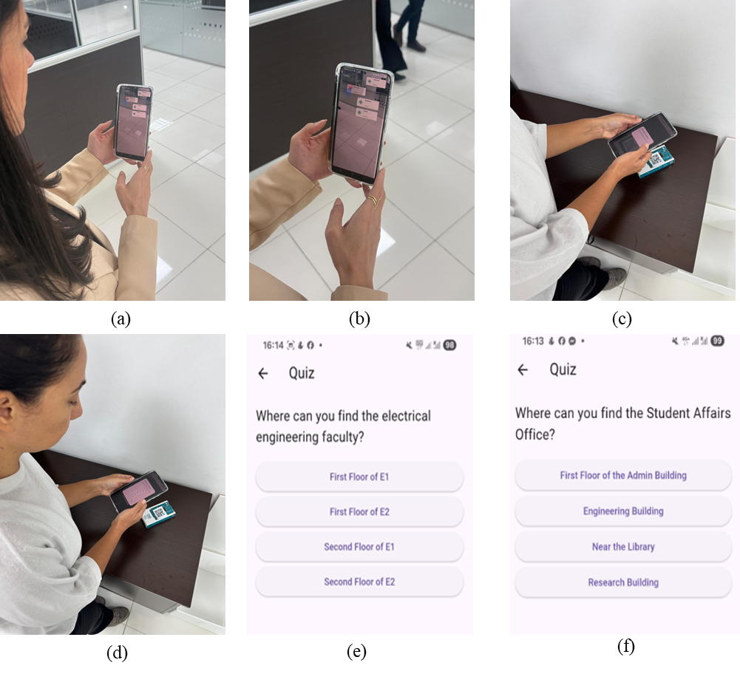

References
[1] M. Nadeem, M. Oroszlányová, A. Lushi, and W. A. Farag, “Bridging the gap: Analyzing skill demands in Kuwait’s electrical engineering job market to enhance employability of graduates,” Industry and Higher Education, vol. 39, no. 5, pp. 550–567, 2025.
[2] M. Nadeem, A. Chandra, A. Livirya, and S. Beryozkina, “AR-LaBOR: Design and assessment of an augmented reality application for lab orientation,” Educ Sci (Basel), vol. 10, no. 11, p. 316, 2020.
[3] C. Feilberg, “In deep water: university students’ challenges in the processes of self-formation, survival or flight,” in Educational Dilemmas, Routledge, 2019, pp. 126–138.
[4] S. P. Moe, “Design and evaluation of a user-centric information system: Enhancing student life with mobile computing,” 2009, Institutt for datateknikk og informasjonsvitenskap.
[5] M. Mohzana, “The impact of the new student orientation program on the adaptation process and academic performance,” International Journal of Educational Narratives, vol. 2, no. 2, pp. 169–178, 2024.
[6] Department of Education, “Student services and amenities fee (SSAF) and SA-HELP,” Australian Government.
[7] Fortune Business Insights, “ugmented Reality Market Size, Share, Growth | Forecast [2024-2032],” 2024.
[8] R. Rashid, N. Annamalali, H. Saed, B. Yassin, and O. Alsmadi, “Developing an interactive university orientation app: Potential users’ feedback,” International Journal of Interactive Mobile Technologies, vol. 15, no. 22, pp. 165–171, 2021.
[9] P. Milgram, H. Takemura, A. Utsumi, and F. Kishino, “Augmented reality: A class of displays on the reality-virtuality continuum,” in Telemanipulator and telepresence technologies, Spie, 1995, pp. 282–292.
[10] A. Ulucan, K. B. Atici, and S. B. Sarac, “A university-wide orientation course timetabling model and its modification for pandemic period,” Opsearch, vol. 60, no. 4, pp. 1575–1602, 2023.
[11] N. Crozier, “Designing effective online orientation programs for first-year university students,” 2021.
[12] S. O. Mercer and A. La Marca, “Exploring Future Teachers’ Acceptance of Wearable Technologies for Anxiety and Stress Management: A TAM-Based Study”.
[13] Q. N. Naveed, H. Choudhary, N. Ahmad, J. Alqahtani, and A. I. Qahmash, “Mobile learning in higher education: A systematic literature review,” Sustainability, vol. 15, no. 18, p. 13566, 2023.
[14] L. Briz-Ponce, A. Pereira, L. Carvalho, J. A. Juanes-Méndez, and F. J. García-Peñalvo, “Learning with mobile technologies–Students’ behavior,” Comput Human Behav, vol. 72, pp. 612–620, 2017.
[15] M. Nadeem, M. Lal, J. Cen, and M. Sharsheer, “AR4FSM: Mobile augmented reality application in engineering education for finite-state machine understanding,” Educ Sci (Basel), vol. 12, no. 8, p. 555, 2022.
[16] A. Dwinggo Samala, L. Bojić, D. Bekiroğlu, R. Watrianthos, and Y. Hendriyani, “Microlearning: Transforming education with bite-sized learning on the go—insights and applications,” International Journal of Interactive Mobile Technologies (iJIM), vol. 17, no. 21, 2023.
[17] V. P. Chandran et al., “Mobile applications in medical education: A systematic review and meta-analysis,” PLoS One, vol. 17, no. 3, p. e0265927, 2022.
[18] Y.-T. Sung, J.-M. Yang, and H.-Y. Lee, “The effects of mobile-computer-supported collaborative learning: Meta-analysis and critical synthesis,” Rev Educ Res, vol. 87, no. 4, pp. 768–805, 2017.
[19] M. Nadeem, W. Farag, Z. Uykan, and M. Helal, “Applications of machine learning in operational aspects of academia: a review,” International Journal of Evaluation and Research in Education (IJERE), vol. 13, no. 5, pp. 2843–2863, 2024, doi: http://doi.org/10.11591/ijere.v13i5.29324.
[20] C. J. Hegarty, “The global positioning system (GPS),” in Springer handbook of global navigation satellite systems, Springer, 2017, pp. 197–218.
[21] T. J. Soon, “QR code,” synthesis journal, vol. 2008, no. 3, pp. 59–78, 2008.
[22] C. Bhadane and K. Shah, “Context-aware next location prediction using data mining and metaheuristics,” Evol Intell, vol. 14, no. 2, pp. 871–880, 2021.
[23] A. I. Regla and B. G. Dadiz, “Online Courier Management System with Text Blast and QR Code Technology,” in 2022 IEEE International Conference on Artificial Intelligence in Engineering and Technology (IICAIET), IEEE, 2022, pp. 1–6.
[24] L.-C. Chu, C.-L. Lee, and C.-J. Wu, “Applying QR code technology to facilitate hospital medical equipment repair management,” in 2012 International Conference on Control Engineering and Communication Technology, IEEE, 2012, pp. 856–859.
[25] F. Alsubaiei, A. Alhendi, K. Alkhalifa, S. Alsharaf, A. Alfoudari, and M. Nadeem, “OGAR: Augmented Reality Application for Assisting Workers in the Oil and Gas Industry,” Proceedings of the IEEE International Multi Topic Conference, INMIC, no. 2024, 2024, doi: 10.1109/INMIC64792.2024.11004414.
[26] N. Nguyen, T. Muilu, A. Dirin, and A. Alamäki, “An interactive and augmented learning concept for orientation week in higher education,” International Journal of Educational Technology in Higher Education, vol. 15, no. 1, pp. 1–15, 2018, doi: 10.1186/s41239-018-0118-x.
[27] S. Feiner, B. MacIntyre, T. Höllerer, and A. Webster, “A touring machine: Prototyping 3D mobile augmented reality systems for exploring the urban environment,” Personal Technologies, vol. 1, pp. 208–217, 1997.
[28] T.-L. Chou and L.-J. ChanLin, “Augmented reality smartphone environment orientation application: a case study of the Fu-Jen University mobile campus touring system,” Procedia-Social and Behavioral Sciences, vol. 46, pp. 410–416, 2012.
[29] D. Li, M.-C. Chuah, and L. Tian, “Lehigh explorer augmented campus tour (LACT),” in Proceedings of the 2014 workshop on Mobile augmented reality and robotic technology-based systems, 2014, pp. 15–16.
[30] C. G. Low and Y. L. Lee, “SunMap+: An intelligent location-based virtual indoor navigation system using augmented reality,” 2014.
[31] A. Iriarte-Solis, P. González-Villegas, R. Fuentes-Covarrubias, and G. Fuentes-Covarrubias, “Mobile Guide to Augmented Reality for Campus of the Autonomous University of Nayarit,” in 2016 IEEE International Symposium on Mixed and Augmented Reality (ISMAR-Adjunct), IEEE, 2016, pp. 1–4.
[32] F. G. Hamza-Lup, J. P. Rolland, and C. Hughes, “A distributed augmented reality system for medical training and simulation,” arXiv preprint arXiv:1811.12815, 2018.
[33] J. T. Chao, L. Pan, and K. R. Parker, “Campus event app-new exploration for mobile augmented reality,” Issues in Informing Science and Information Technology, vol. 11, no. 1, pp. 1–11, 2014.
[34] K.-M. Yu, J.-C. Chiu, M.-G. Lee, and S.-S. Chi, “A mobile application for an ecological campus navigation system using augmented reality,” in 2015 8th International Conference on Ubi-Media Computing (UMEDIA), IEEE, 2015, pp. 17–22.
[35] B. Al Delail, L. Weruaga, and M. J. Zemerly, “CAViAR: Context aware visual indoor augmented reality for a university campus,” in 2012 IEEE/WIC/ACM International Conferences on Web Intelligence and Intelligent Agent Technology, IEEE, 2012, pp. 286–290.
[36] F. D. Giraldo, E. Arango, C. D. Cruz, and C. C. Bernal, “Application of augmented reality and usability approaches for the implementation of an interactive tour applied at the University of Quindio,” in 2016 IEEE 11th Colombian Computing Conference (CCC), IEEE, 2016, pp. 1–8.
[37] J. Garay-Cortes and A. Uribe-Quevedo, “Location-based augmented reality game to engage students in discovering institutional landmarks,” in 2016 7th International Conference on Information, Intelligence, Systems & Applications (IISA), IEEE, 2016, pp. 1–4.
[38] U. Özcan, A. Arslan, M. İlkyaz, and E. Karaarslan, “An augmented reality application for smart campus urbanization: MSKU campus prototype,” in 2017 5th International Istanbul Smart Grid and Cities Congress and Fair (ICSG), Ieee, 2017, pp. 100–104.
[39] C. Andri, M. H. Alkawaz, and S. R. Waheed, “Examining effectiveness and user experiences in 3d mobile based augmented reality for msu virtual tour,” in 2019 IEEE International Conference on Automatic Control and Intelligent Systems (I2CACIS), IEEE, 2019, pp. 161–167.
[40] C. Carbonell Carrera and L. A. Bermejo Asensio, “Landscape interpretation with augmented reality and maps to improve spatial orientation skill,” Journal of Geography in Higher Education, vol. 41, no. 1, pp. 119–133, 2017.
[41] M. Batty and P. Kyaw, “Vector-based location finding for context-aware campus,” in 2009 Fifth International Conference on Wireless and Mobile Communications, IEEE, 2009, pp. 116–121.
[42] A. Walsh, “QR Codes–using mobile phones to deliver library instruction and help at the point of need.,” Journal of information literacy, vol. 3, no. 1, pp. 55–65, 2010.
[43] J. Lave, “Situating learning in communities of practice.,” 1991.
[44] M. Dunleavy, C. Dede, and R. Mitchell, “Affordances and limitations of immersive participatory augmented reality simulations for teaching and learning,” J Sci Educ Technol, vol. 18, no. 1, pp. 7–22, 2009.
[45] R. C. Atkinson and R. M. Shiffrin, “Human memory: A proposed system and its control processes,” in Psychology of learning and motivation, vol. 2, Elsevier, 1968, pp. 89–195.
[46] H.-K. Wu, S. W.-Y. Lee, H.-Y. Chang, and J.-C. Liang, “Current status, opportunities and challenges of augmented reality in education,” Comput Educ, vol. 62, pp. 41–49, 2013.
[47] E. Tenner, “The design of everyday things by Donald Norman,” Technol Cult, vol. 56, no. 3, pp. 785–787, 2015.
[48] J. L. Bacca Acosta, S. M. Baldiris Navarro, R. Fabregat Gesa, and S. Graf, “Augmented reality trends in education: a systematic review of research and applications,” Journal of Educational Technology and Society, 2014, vol. 17, núm. 4, p. 133-149, 2014.
[49] D. R. Montello, “Cognition of geographic information,” in A research agenda for geographic information science, CRC Press, 2004, pp. 61–91.
[50] F. D. Davis, “Perceived usefulness, perceived ease of use, and user acceptance of information technology,” MIS quarterly, pp. 319–340, 1989.
[51] F. D. Davis, A. Granić, and N. Marangunić, “The technology acceptance model 30 years of TAM,” Technology (Singap World Sci), vol. 1, no. 1, pp. 1–150, 2023.
[52] A. Tashildar, N. Shah, R. Gala, T. Giri, and P. Chavhan, “Application development using flutter,” International Research Journal of Modernization in Engineering Technology and Science, vol. 2, no. 8, pp. 1262–1266, 2020.
[53] A. TĂBUȘCĂ, C. Coculescu, and M. Pîrnău, “FLUTTER TECHNOLOGY AND MOBILE SOFTWARE APPLICATIONS.,” Journal of Information Systems & Operations Management, vol. 16, no. 2, 2022.
[54] W. Wu, “React Native vs Flutter, Cross-platforms mobile application frameworks,” 2018.
[55] G. Bracha, The Dart programming language. Addison-Wesley Professional, 2015.
[56] P. Bourhis, J. L. Reutter, and D. Vrgoč, “JSON: Data model and query languages,” Inf Syst, vol. 89, p. 101478, 2020.
[57] D. P. Putri, “Augmented Reality Implementation in Financial Regulatory Education for Indonesian High School Students,” Augmented Reality Implementation in Financial Regulatory Education for Indonesian High School Students.
[58] S. B. Bello, M. S. Abdurrahman, and U. S. Bebeji, “Artificial Intelligence in legal Education: Perceptions of ease of use and usefulness of CHATGPT among undergraduate law Students of Ahmadu Bello University, Zaria,” LexScriptio A Journal of the Department of Jurisprudence and Public Law, vol. 2, no. 1, pp. 81–94, 2025.
[59] M. A. M. M. Alsaid, T. M. Ahmed, S. Jan, F. Q. Khan, and A. U. Khattak, “A Comparative Analysis of Mobile Application Development Approaches: Mobile Application Development Approaches,” Proceedings of the Pakistan Academy of Sciences: a. Physical and computational sciences, vol. 58, no. 1, pp. 35–45, 2021.
[60] I. Buchem, F. Schmid, and A. Ermel, “Competency Recognition in AI Education: Investigating Higher Education Students’ Perceptions of Open Educational Badges Using Technology-Acceptance Model.,” Ubiquity Proceedings, vol. 6, no. 1, 2025.
[61] Y. Gong, C. Xu, S. Luo, and J. Lin, “Modeling teacher education students’ adoption of large language models through an extended technology acceptance framework,” Sci Rep, vol. 15, no. 1, p. 32208, 2025.
[62] V. Agate, A. De Paola, G. Lo Re, M. Morana, and A. Virga, “WIP: Context-Aware Recommendations for Smart Campus Environments,” in 2025 IEEE International Conference on Smart Computing (SMARTCOMP), IEEE, 2025, pp. 231–233.
[63] M. Henderson, N. Selwyn, and R. Aston, “What works and why? Student perceptions of ‘useful’digital technology in university teaching and learning,” Studies in higher education, vol. 42, no. 8, pp. 1567–1579, 2017.
[64] N. R. Aljohani, A. Daud, R. A. Abbasi, J. S. Alowibdi, M. Basheri, and M. A. Aslam, “An integrated framework for course adapted student learning analytics dashboard,” Comput Human Behav, vol. 92, pp. 679–690, 2019.
[65] N. Cavus, B. Omonayajo, and M. R. Mutizwa, “Technology Acceptance Model and Learning Management Systems: Systematic Literature Review.,” International Journal of Interactive Mobile Technologies, vol. 17, no. 23, 2022.
[66] T. Shen, H. Chen, and W.-S. Ku, “Time-aware location sequence recommendation for cold-start mobile users,” in Proceedings of the 26th ACM SIGSPATIAL international conference on advances in geographic information systems, 2018, pp. 484–487.
[67] H. Huang, G. Gartner, J. M. Krisp, M. Raubal, and N. Van de Weghe, “Location based services: ongoing evolution and research agenda,” Journal of Location Based Services, vol. 12, no. 2, pp. 63–93, 2018.
[68] J. Nouri, “Students multimodal literacy and design of learning during self-studies in higher education,” Technology, Knowledge and Learning, vol. 24, no. 4, pp. 683–698, 2019.
[69] M. Sarrab and M. Elbasir, “Instruction and learning design consideration for the development of mobile learning application,” World Academy of Science, Engineering and Technology, International Journal of Social, Behavioral, Educational, Economic, Business and Industrial Engineering, vol. 9, no. 8, pp. 2861–2864, 2015.
[70] J. Mtebe and R. Raisamo, “Investigating students’ behavioural intention to adopt and use mobile learning in higher education in East Africa,” International Journal of Education and Development using ICT, vol. 10, no. 3, 2014.
[71] A. Barks, H. R. Searight, and S. Ratwik, “Effects of text messaging on academic performance,” Signum Temporis, vol. 4, no. 1, p. 4, 2011.
[72] L. H. Wong, “Mobile campus touring system based on AR and GPS: A case study of campus cultural activity,” in Proceedings of the 21st International Conference on Computers in Education. Asia-Pacific Society for Computers in Education, Indonesia, 2013.
[73] N. Nordin and M. A. Nordin, “Practical Applications of Augmented Reality in Sustainability,” in Proceeding of International Conference on Science and Technology UISU, 2025, pp. 197–201.

Disclaimer/Publisher’s Note: The statements, opinions and data contained in all publications are solely those of the individual author(s) and contributor(s) and not of MDPI and/or the editor(s). MDPI and/or the editor(s) disclaim responsibility for any injury to people or property resulting from any ideas, methods, instructions or products referred to in the content.

